**Create a Maven Java Project**

1. **Open the New Maven Project Wizard**:
   * Click File → New → Other....
   * Type "Maven" in the search box and select Maven Project. Click Next.

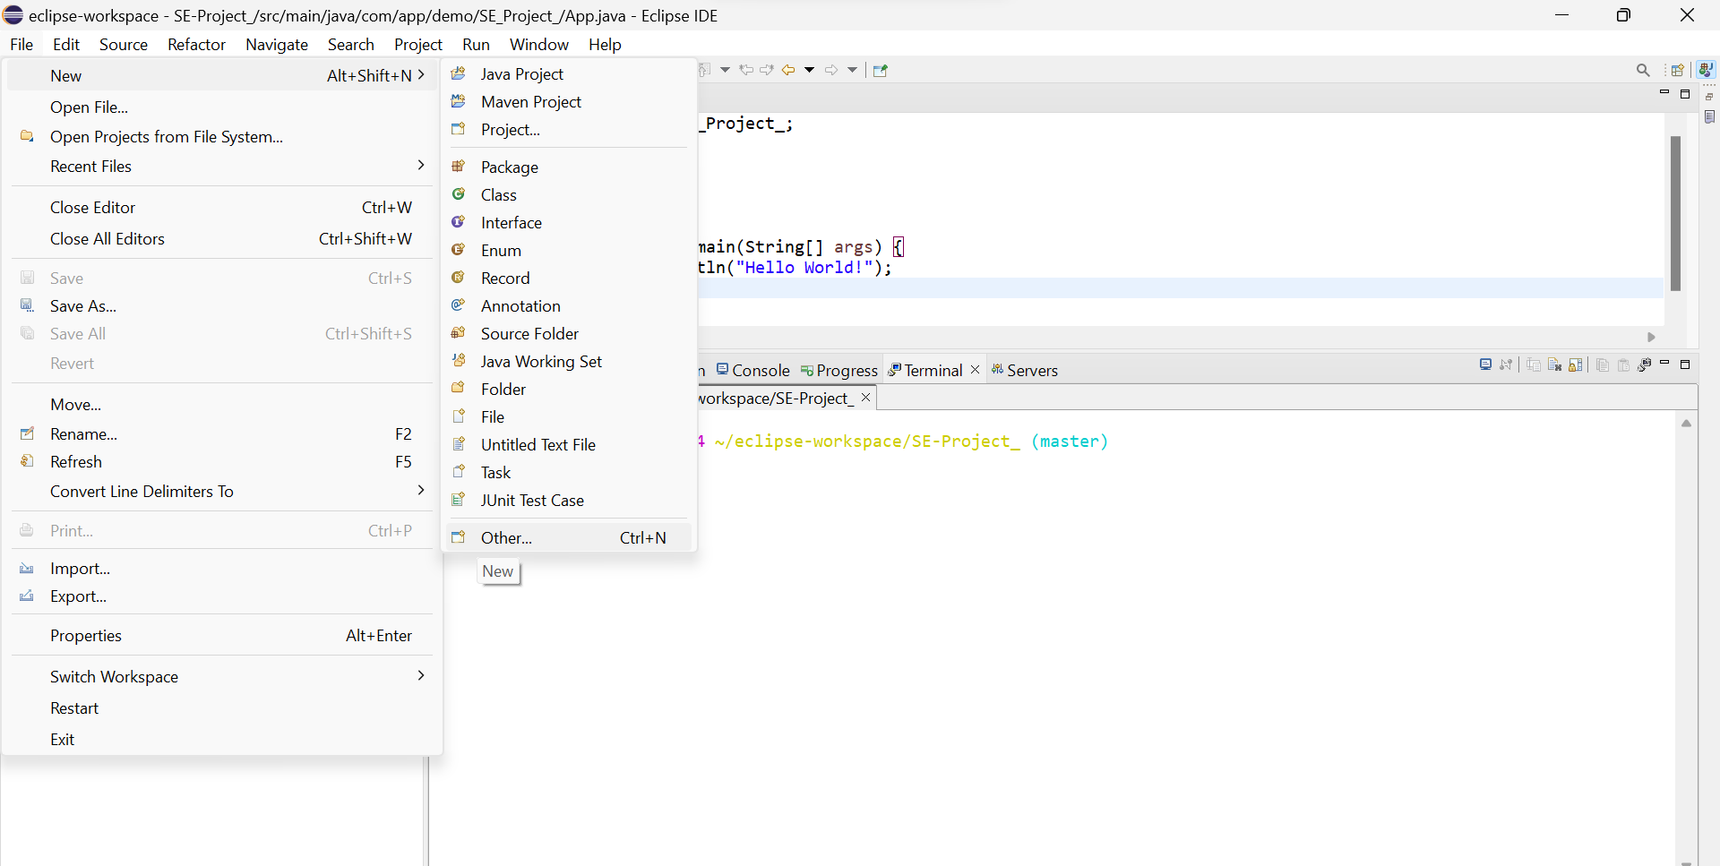

1. **Select Project Location**:

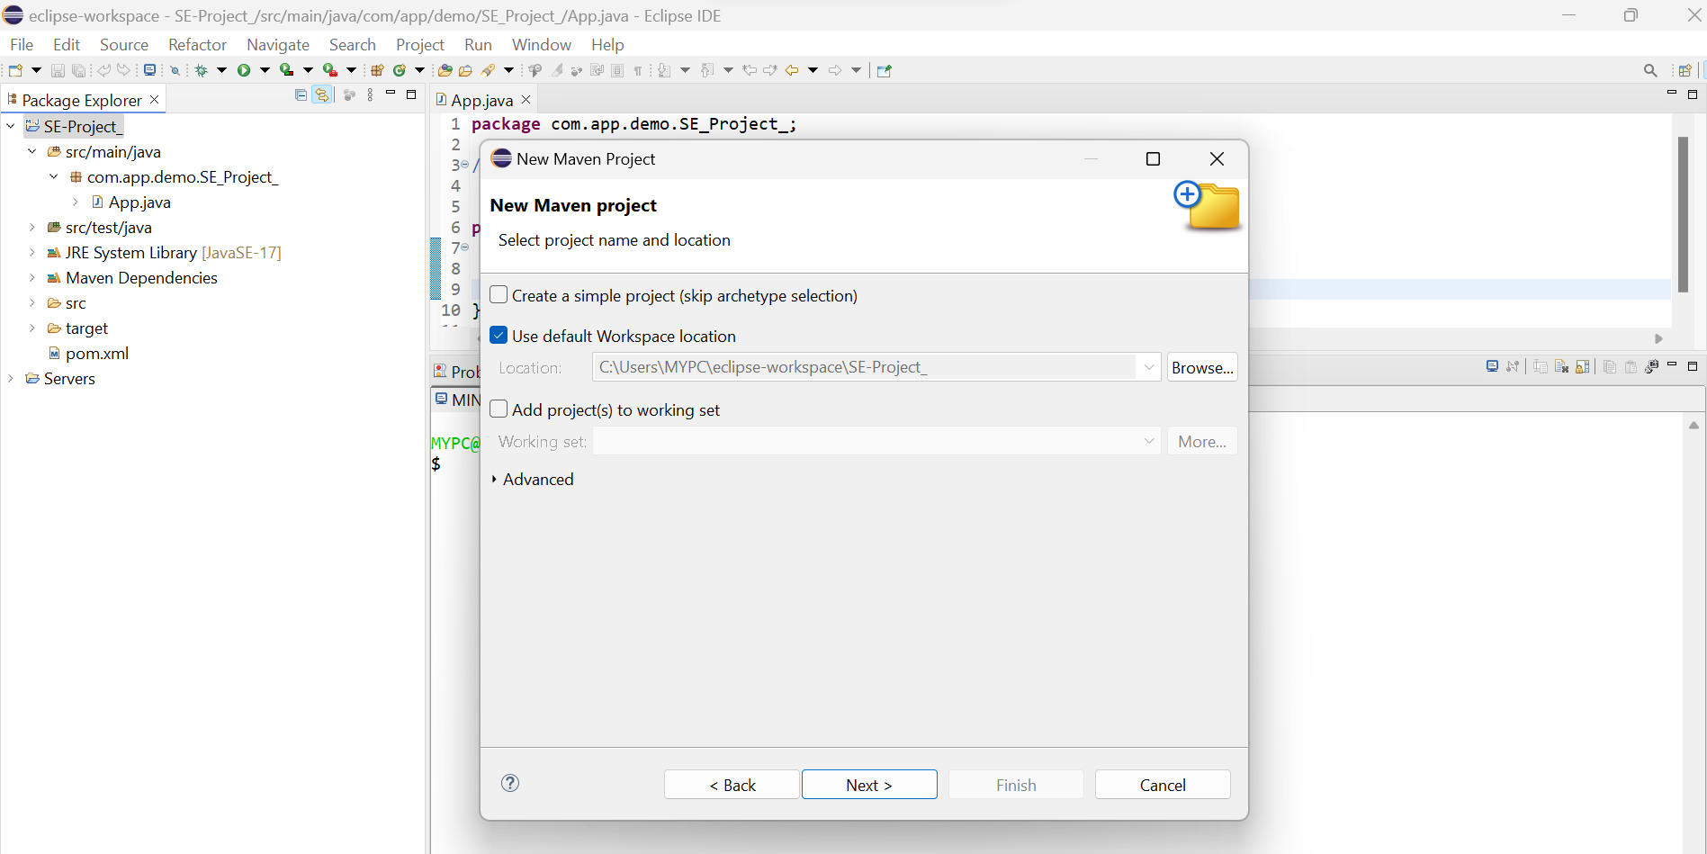

1. **Select an Archetype**:
   * Common archetype: maven-archetype-quickstart (basic project with example code).

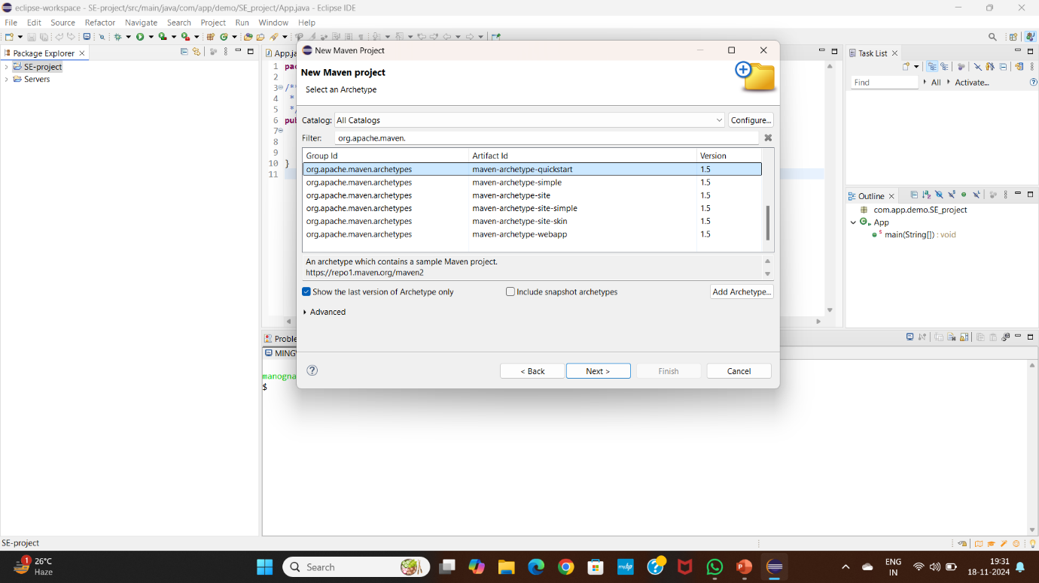

1. **Define Project Coordinates**:
   * **Group ID**: Usually the base package name (e.g., com.example).
   * **Artifact ID**: The name of your project.
   * **Version**: Default is 1.0-SNAPSHOT (can be changed).
   * **Package**: The base package name for your project (e.g., com.example.app).
   * Click Finish.

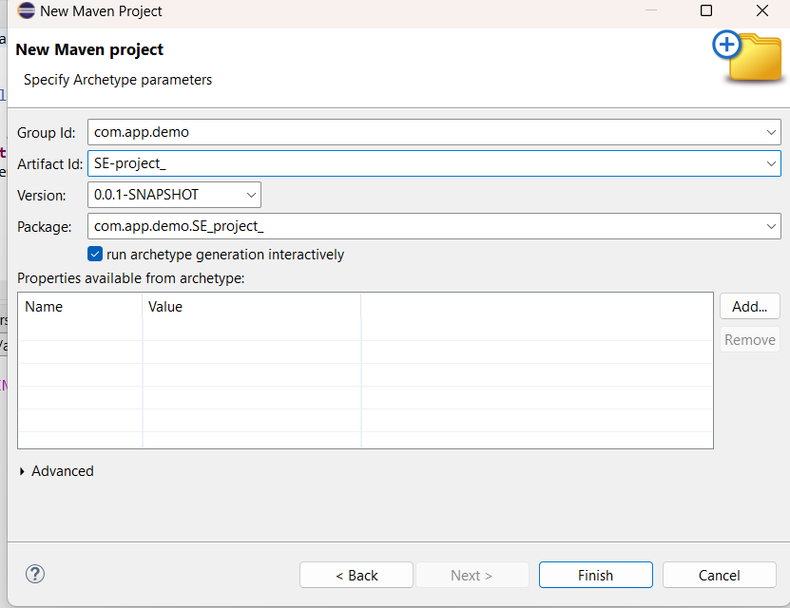

**4.Explore the Maven Project Structure.**

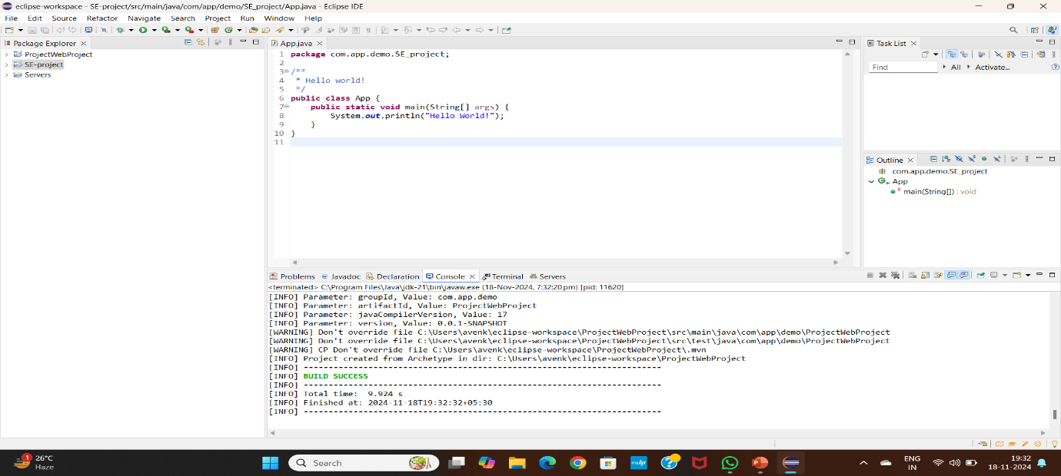

1. **open pom.xml**

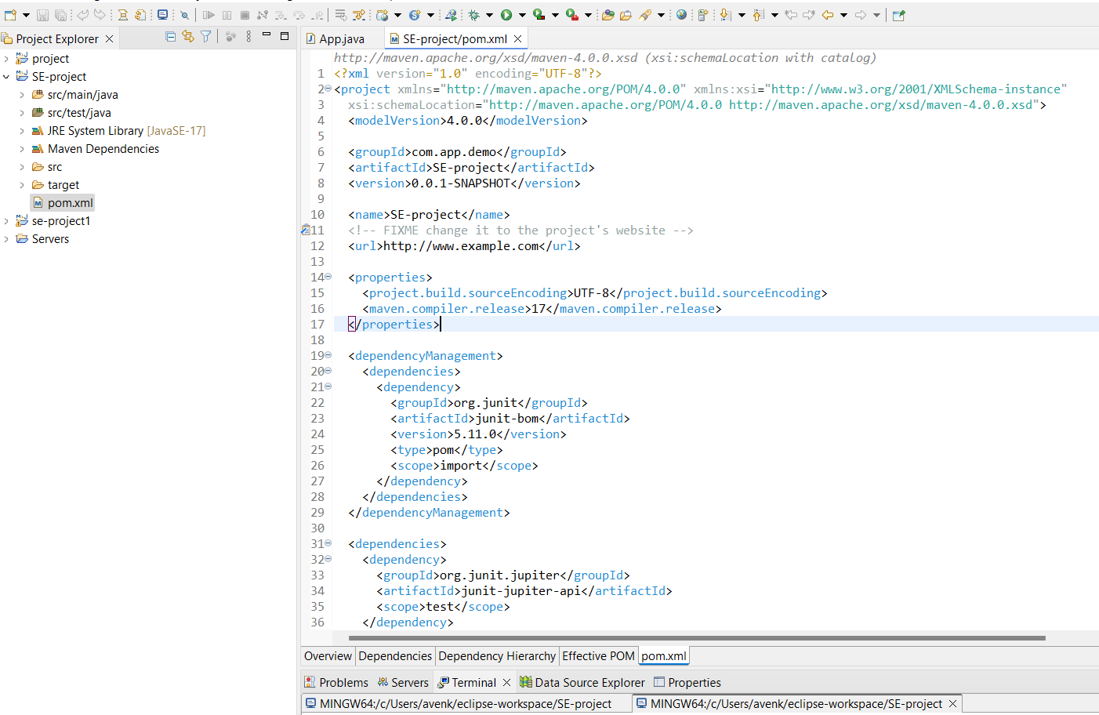

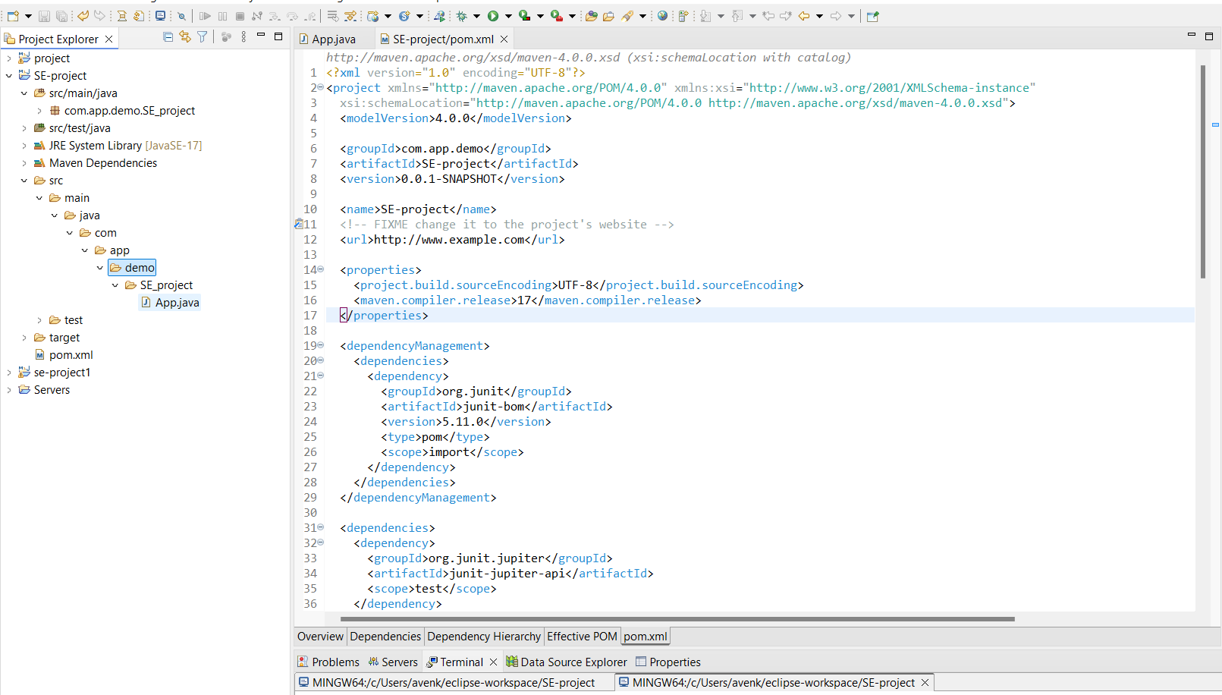

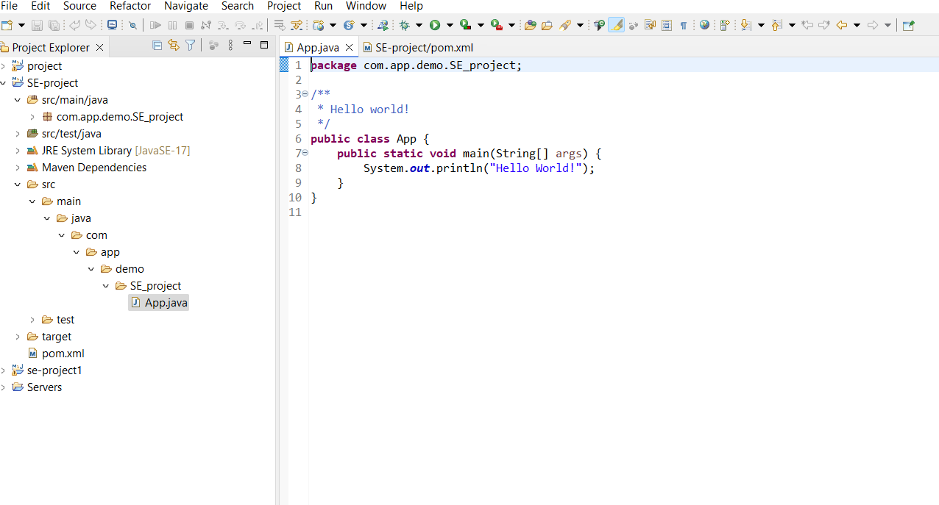

1. **Build the Maven Project**

* Right-click the project → Run As → Maven Clean....

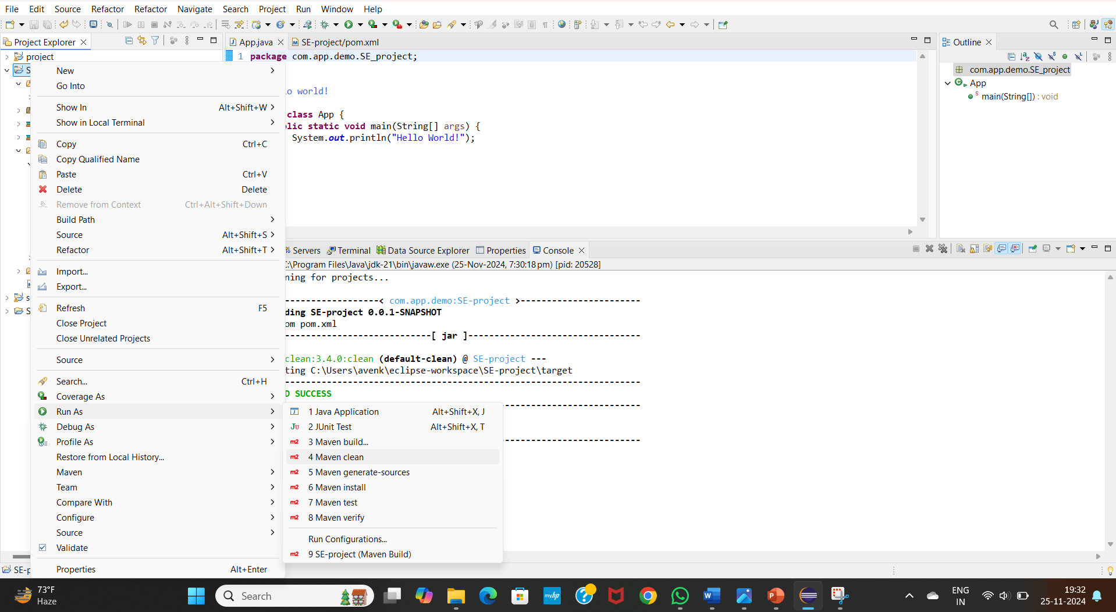

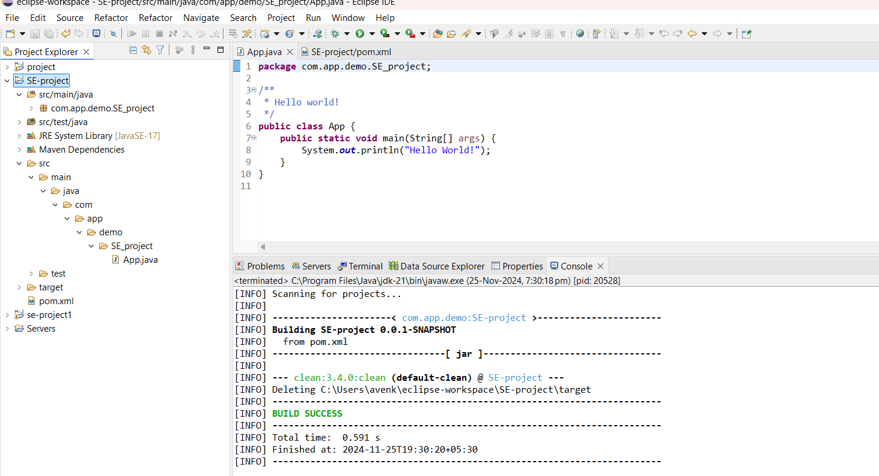

* Right-click the project → Run As → Maven install....

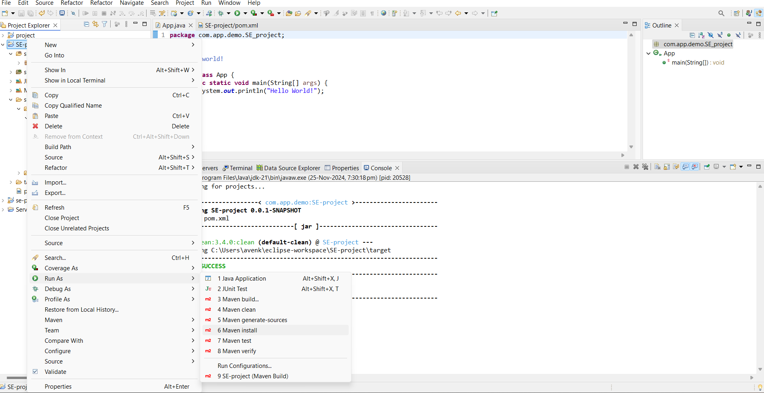

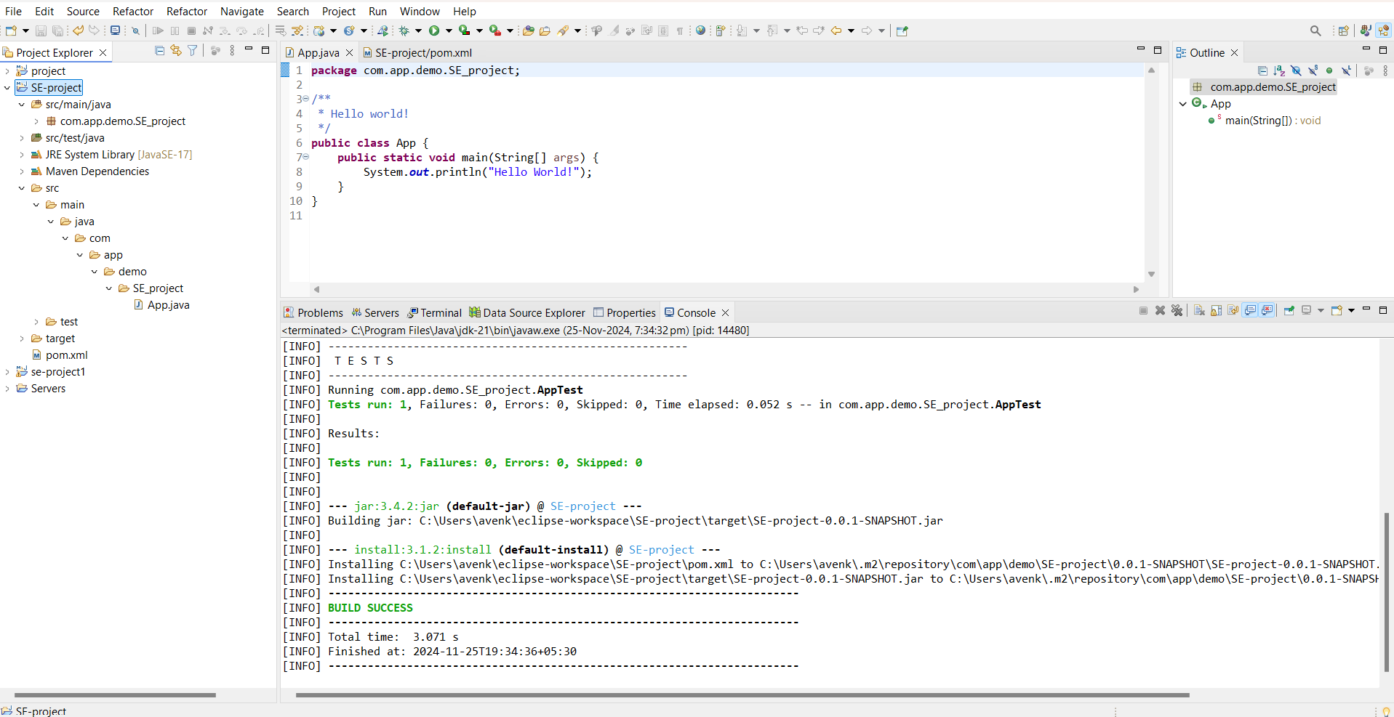

* Right-click the project → Run As → Maven test....

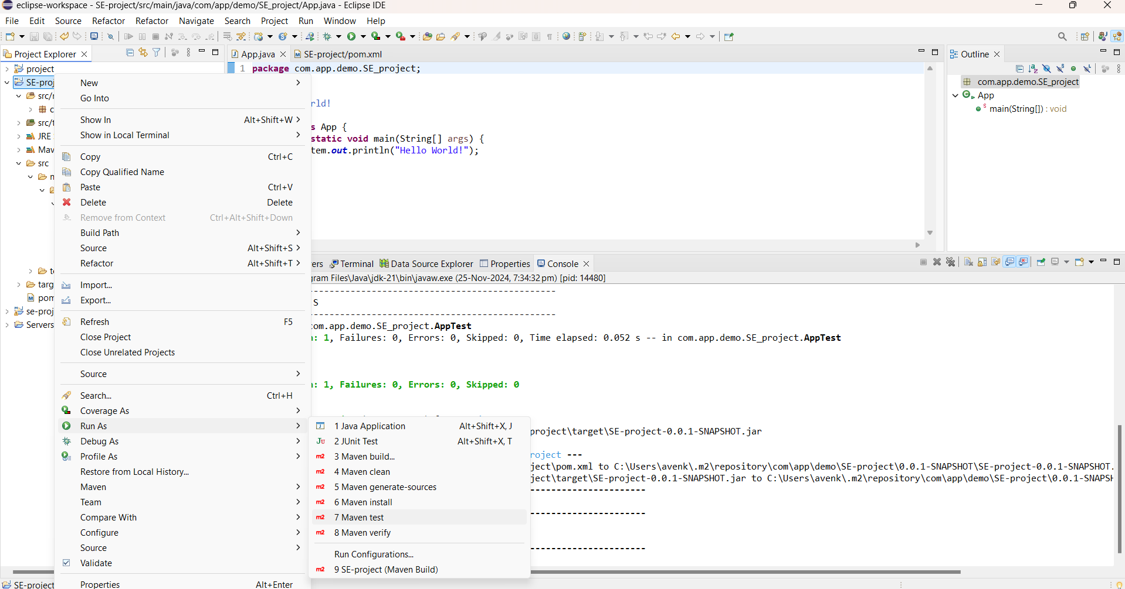

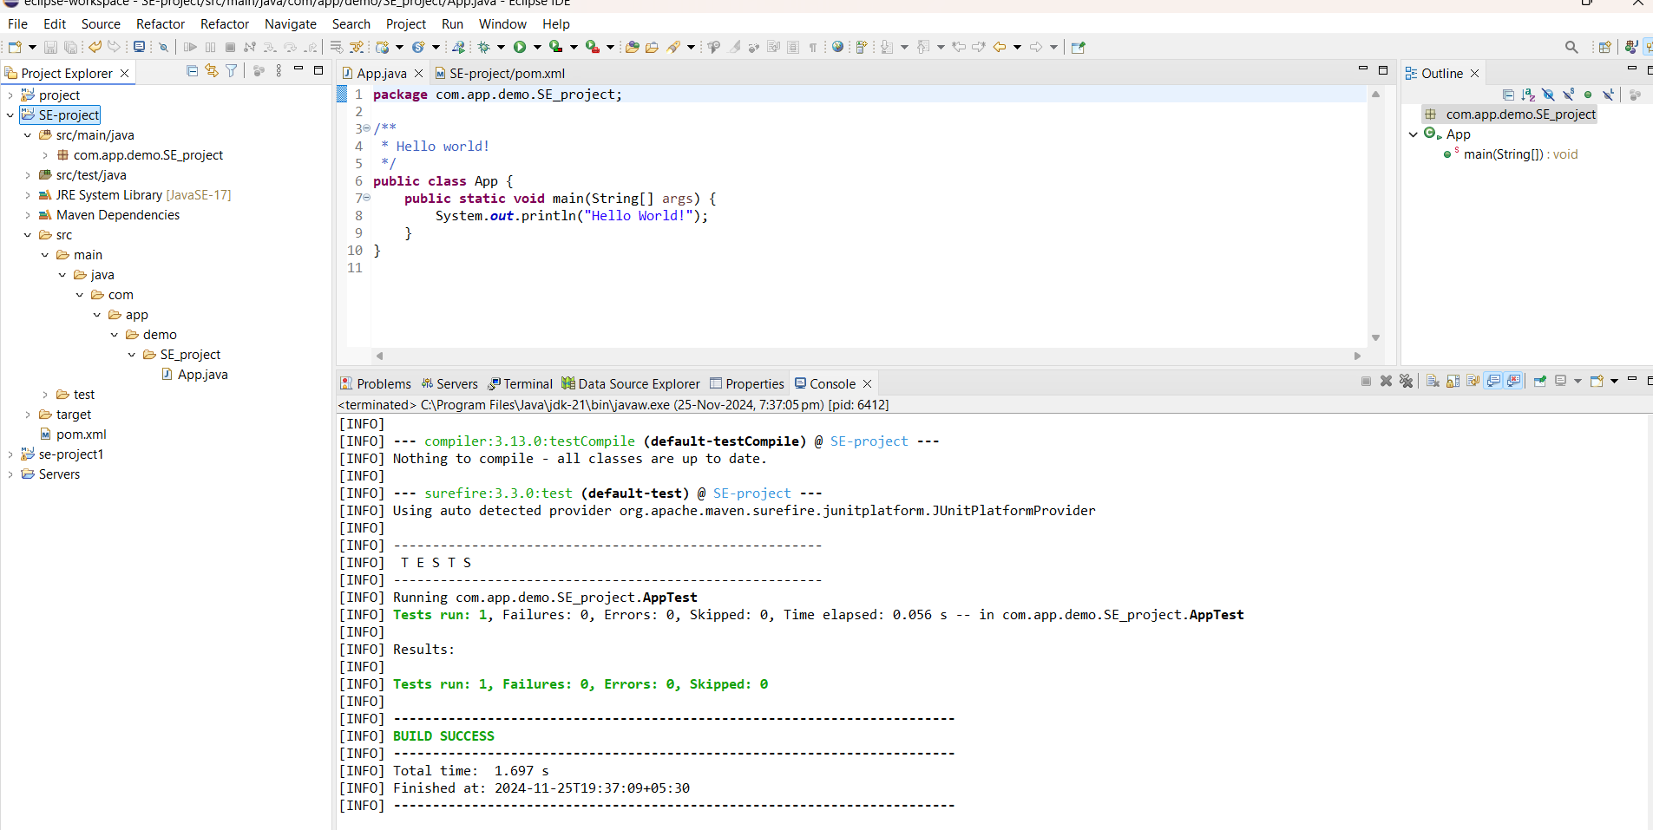

* Right-click the project → Run As → Maven bulid....

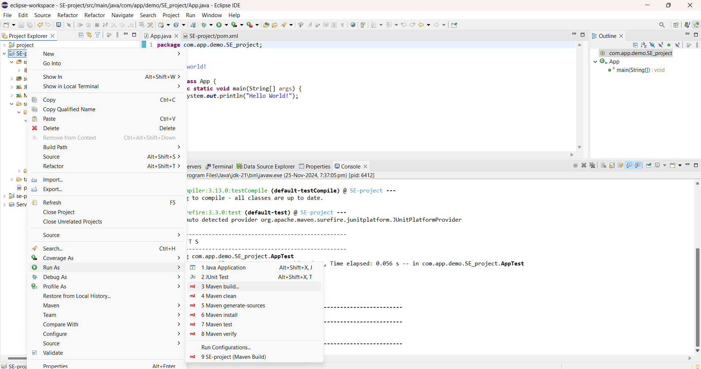

* In the Goals field, type clean install test and click on Run…

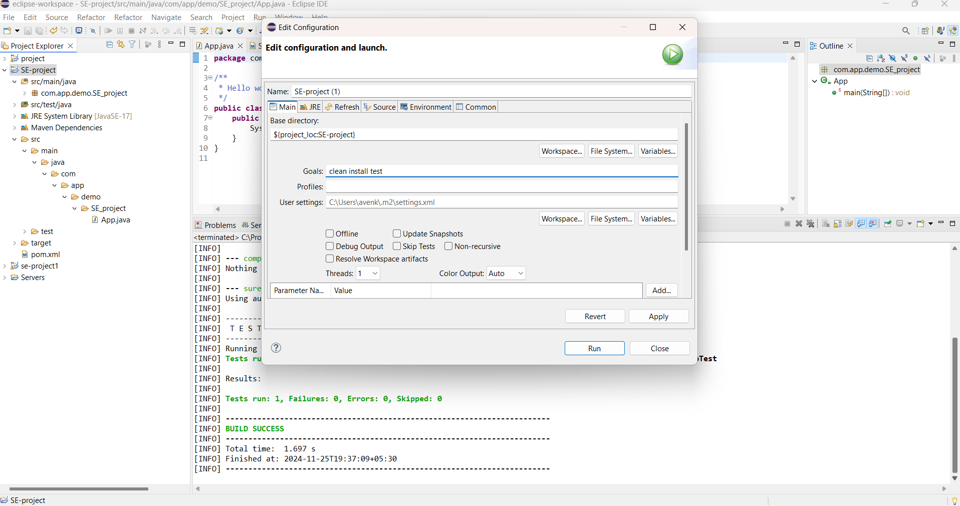

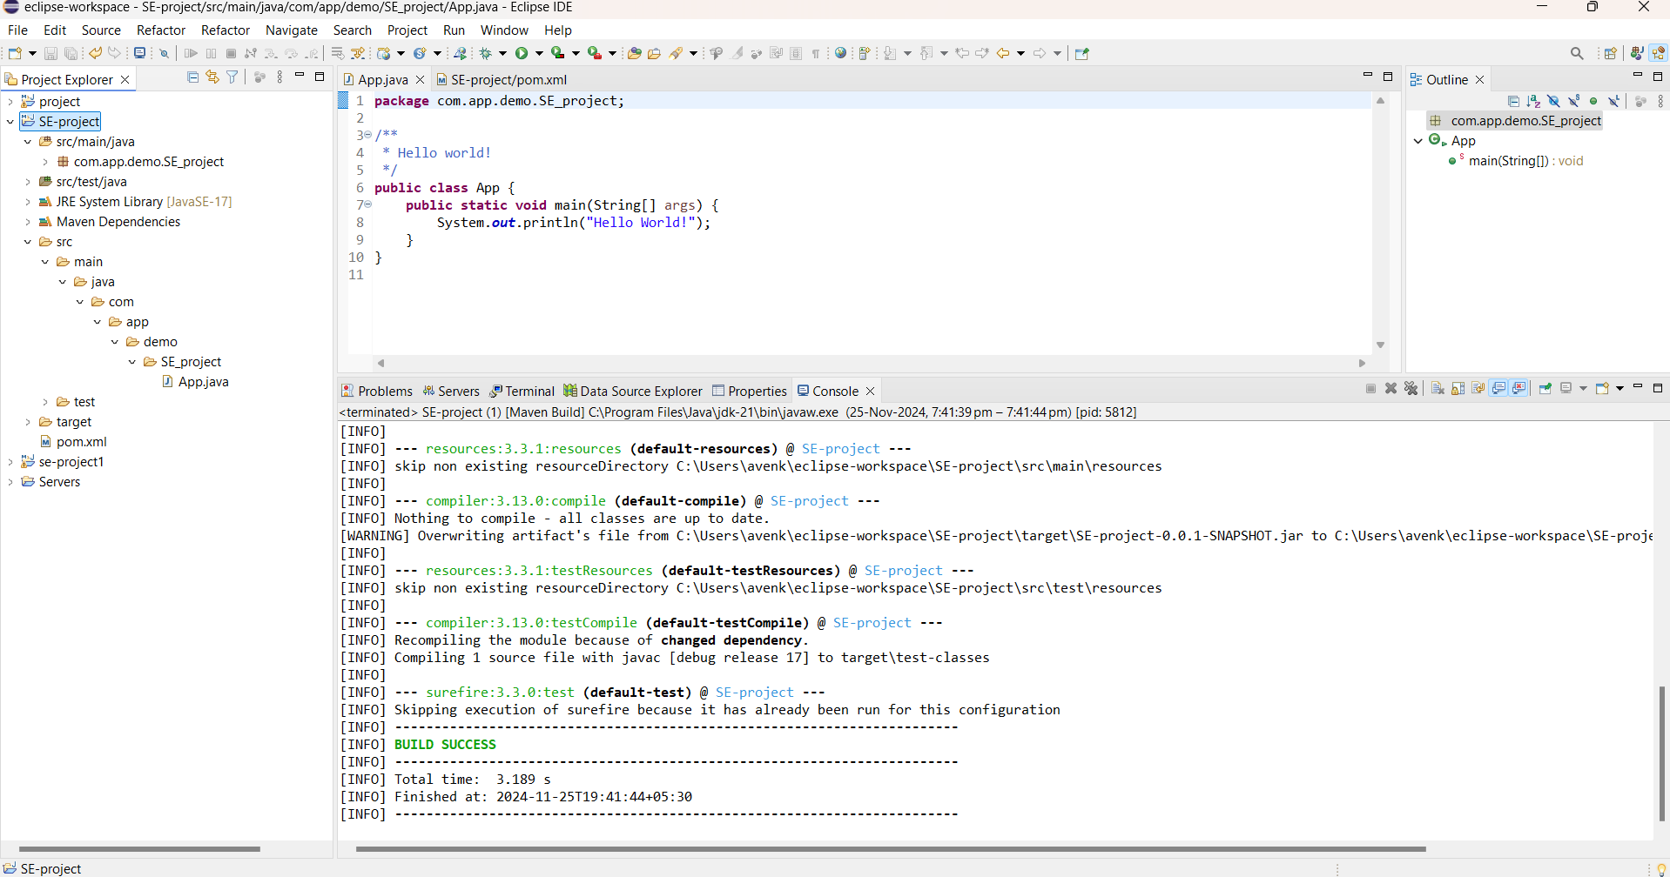

7.Jar file will be created. 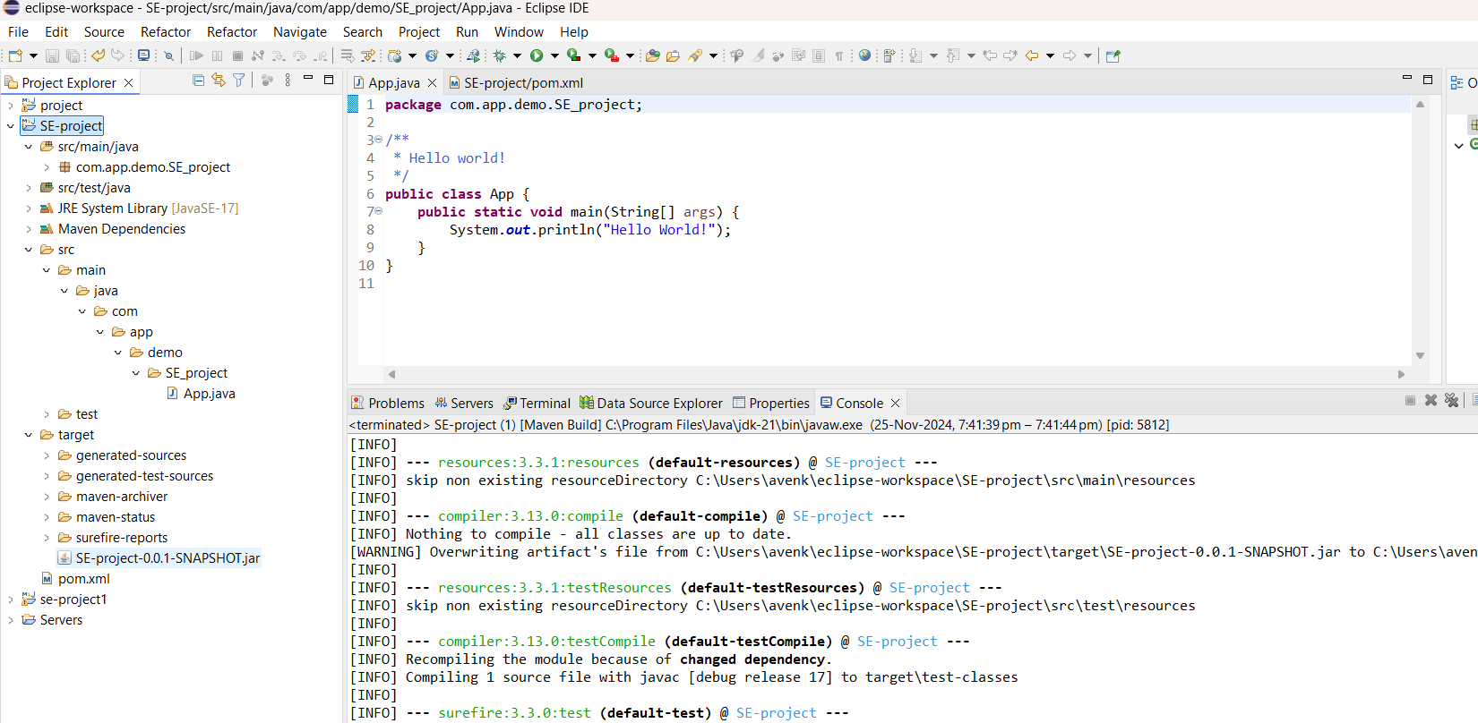

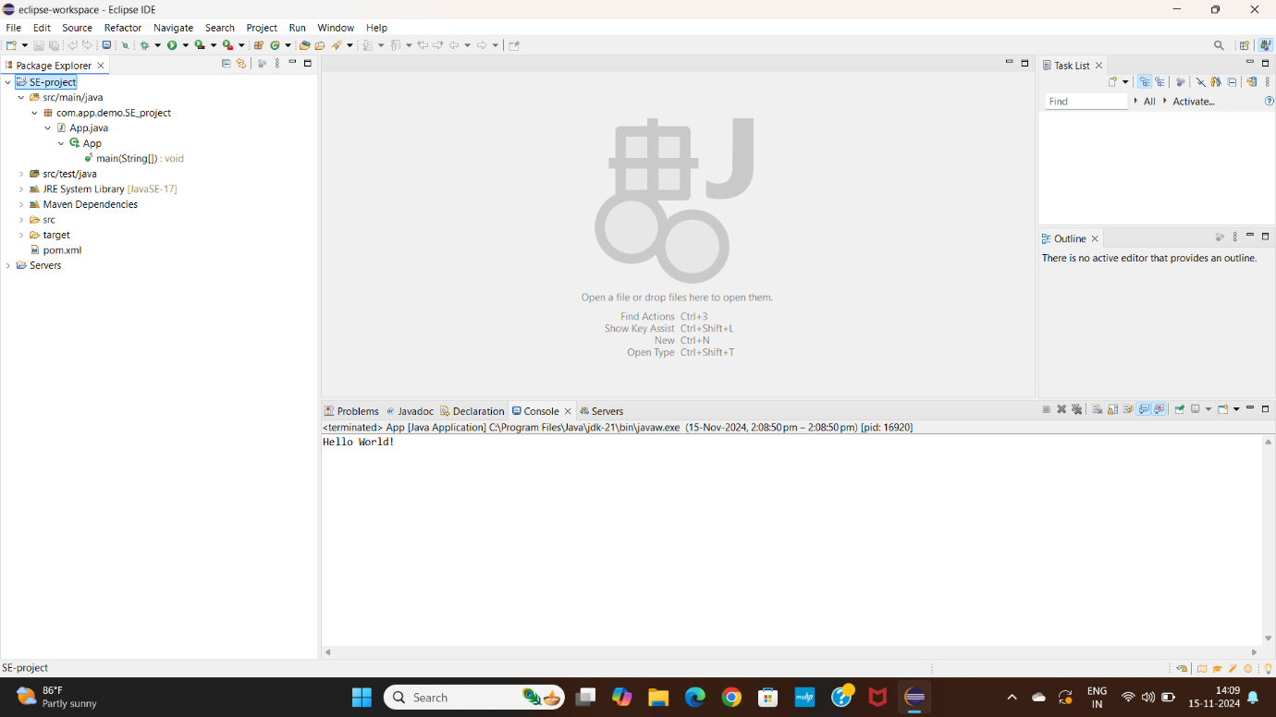

**Push the project into git:**

**1. Initialize a Git Repository**

1. Open a terminal or command prompt in the root directory of your Maven project.
2. Initialize the Git repository.

**2. Stage and Commit Files**

1. Stage all files and commit:

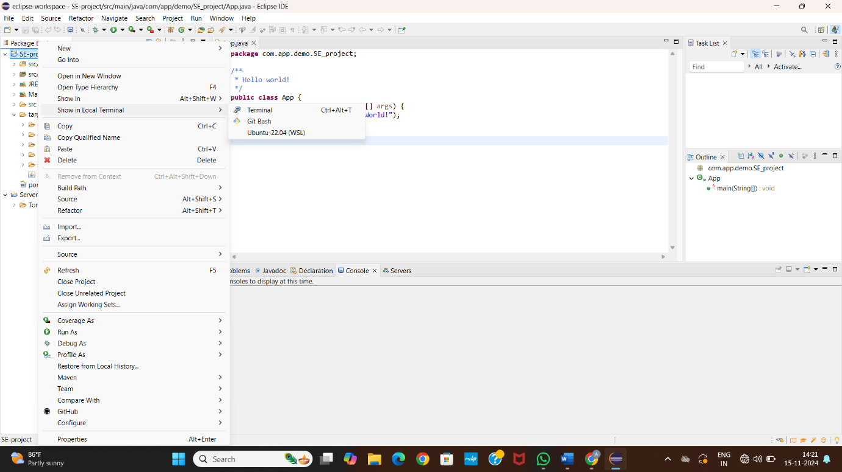

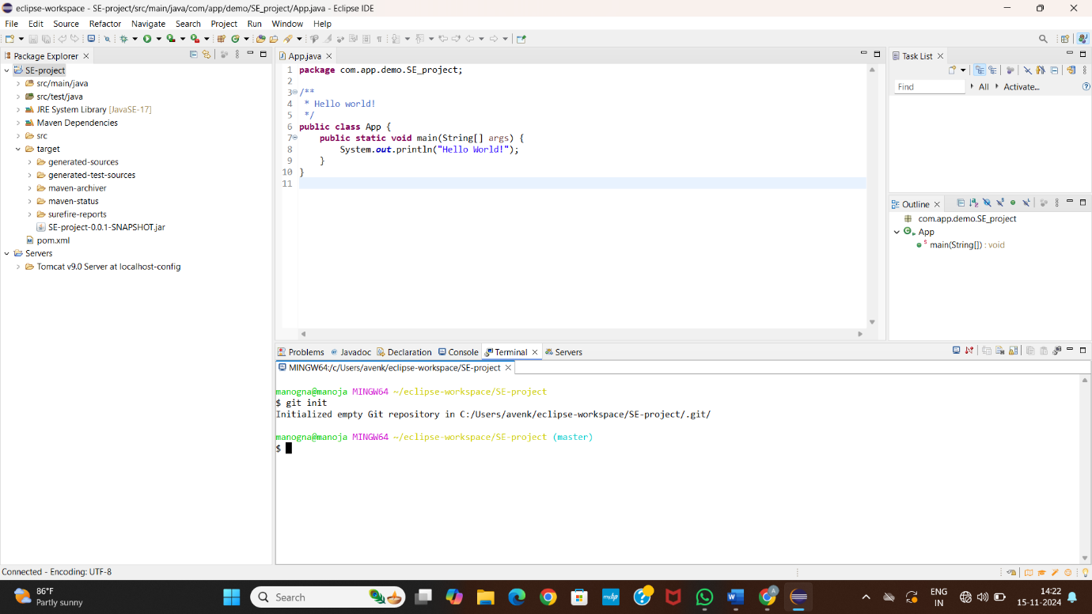

**3. Create a Remote Repository**

1. Go to [GitHub](https://github.com).
2. Create a new repository.

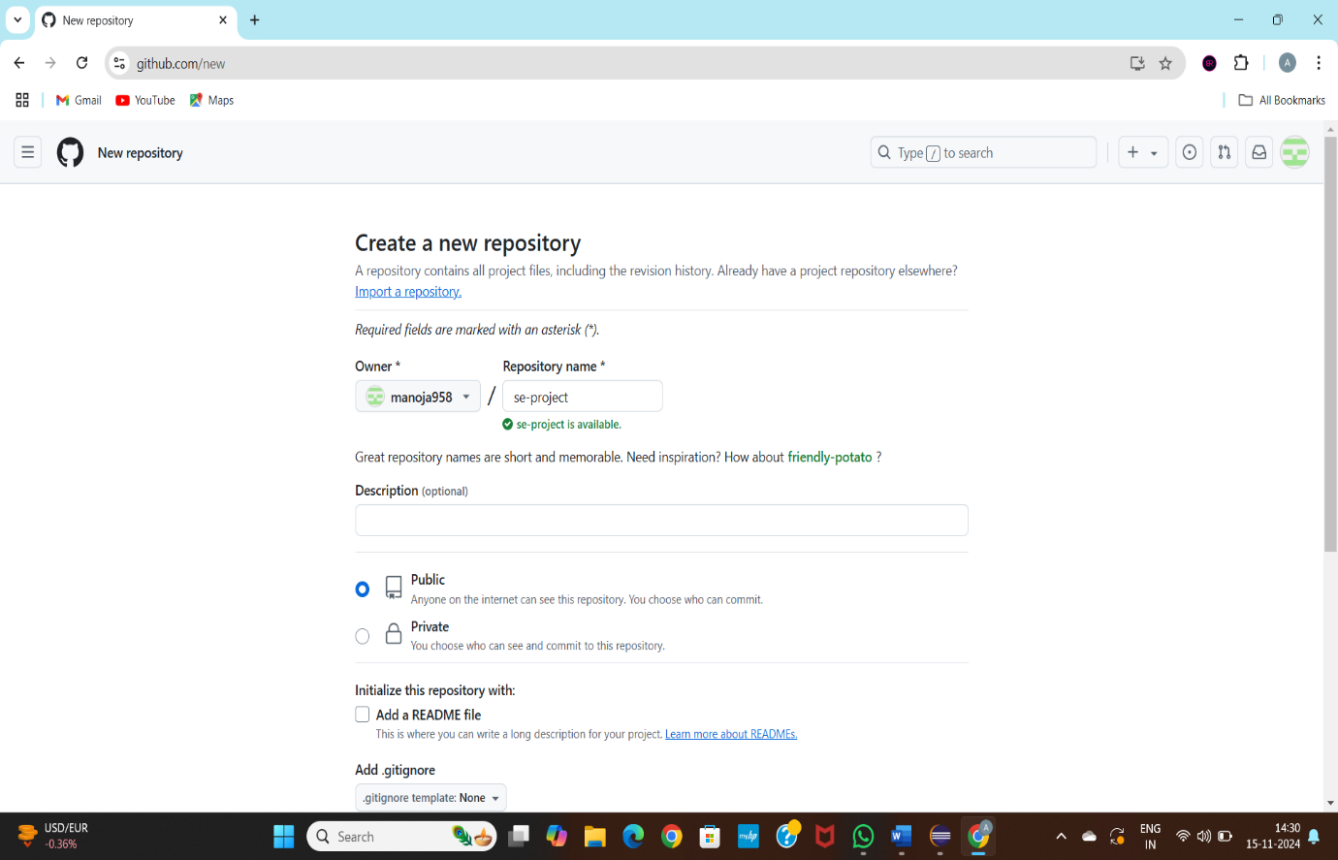

4.Link Local Repo to Remote.

5. Push Your Code.

6. Verify on GitHub.

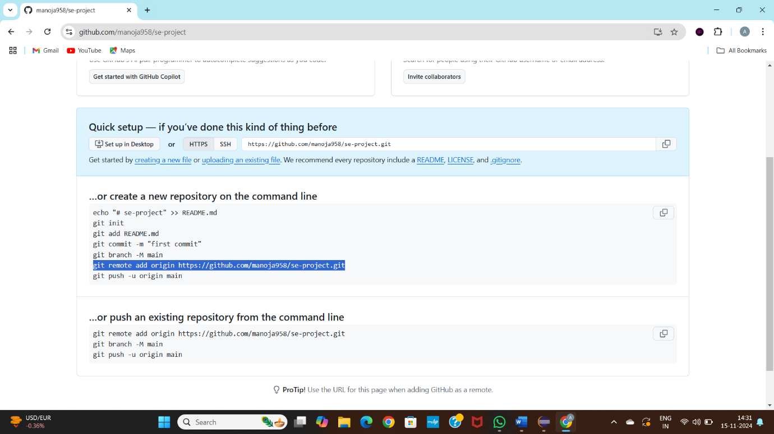

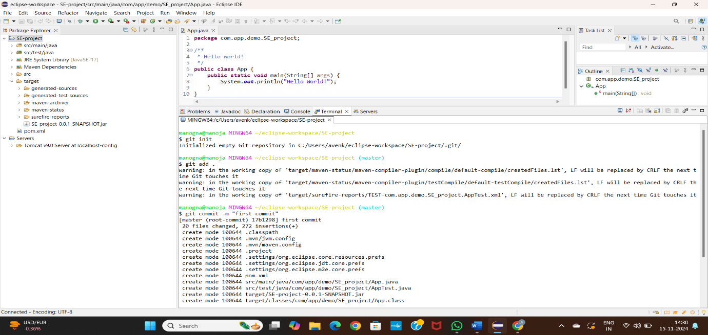

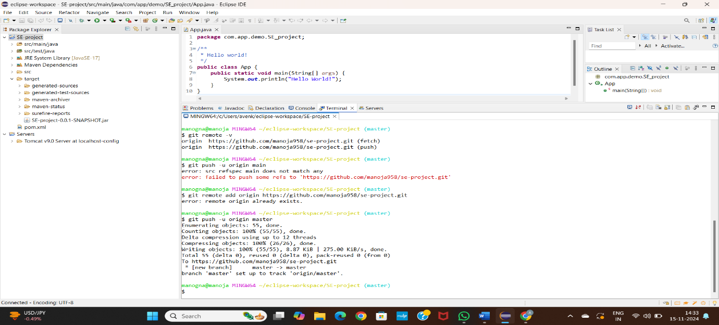

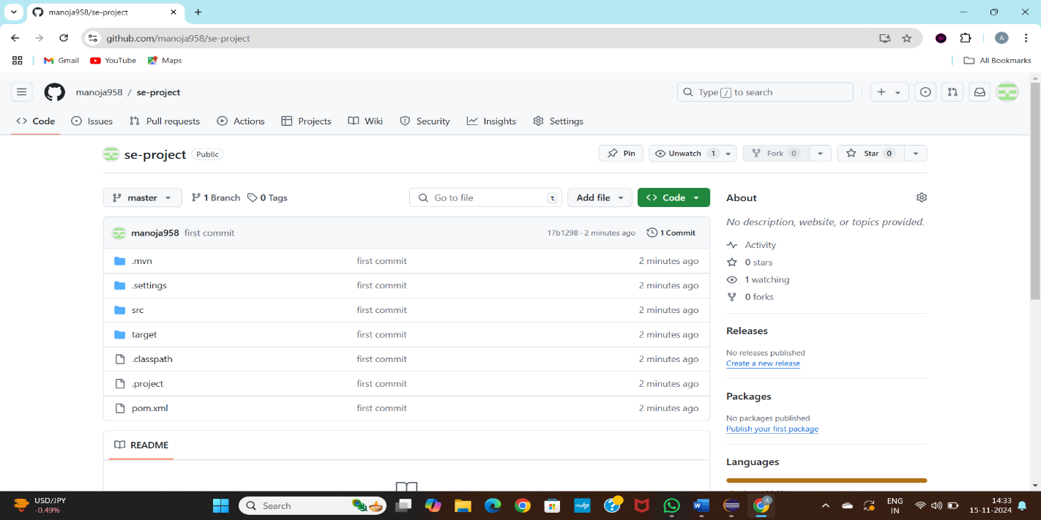

**Create a New Maven Web Project**

1. **Open the New Maven Project Wizard**:
   * Click File → New → Other....
   * Type "Maven" in the search box and select Maven Project. Click Next.

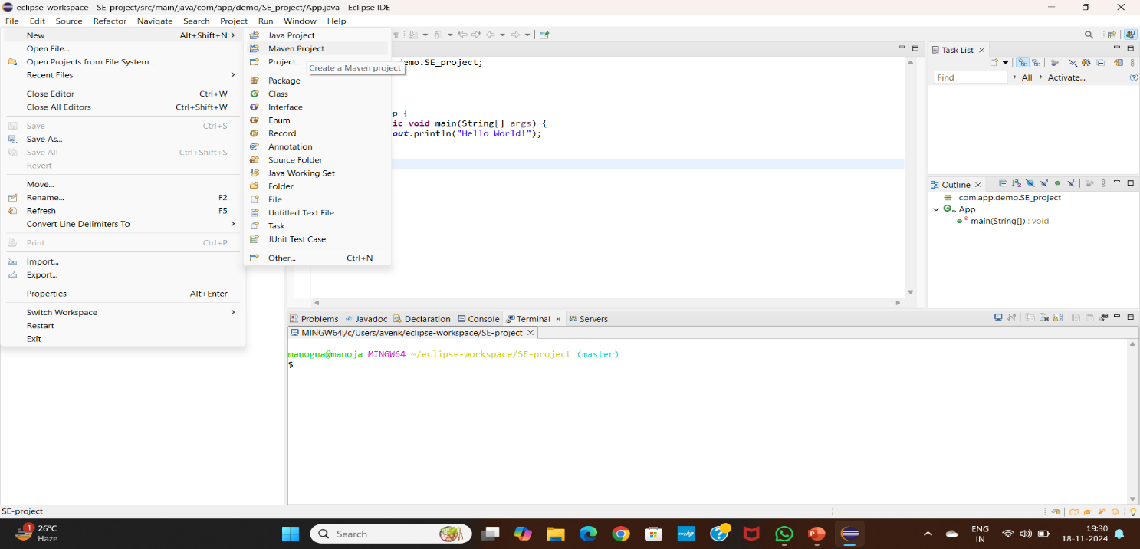

1. **Select Project Location**:

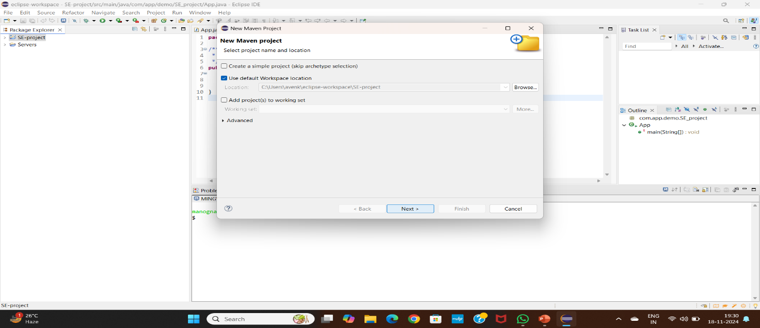

1. **Select an Archetype**:
   * Common archetype: maven-archetype-quickstart (basic project with example code).

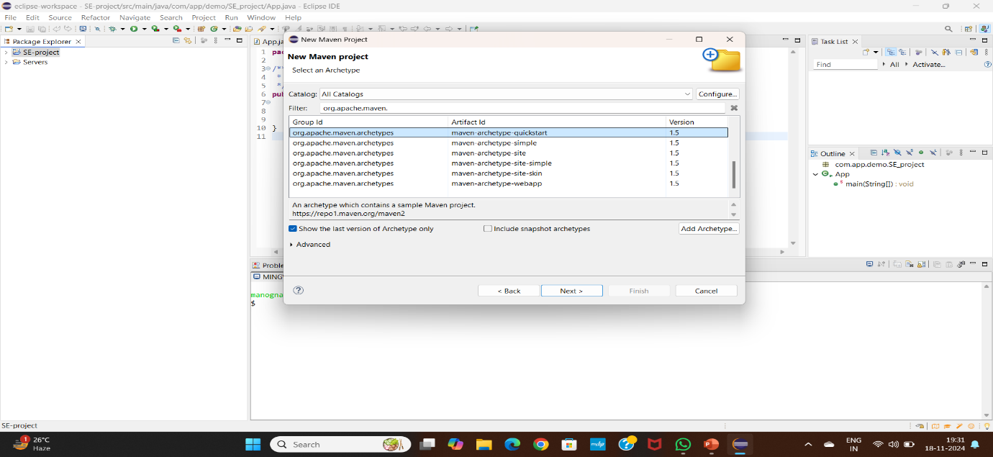

1. **Define Project Coordinates**:
   * **Group ID**: Usually the base package name (e.g., com.example).
   * **Artifact ID**: The name of your project.
   * **Version**: Default is 1.0-SNAPSHOT (can be changed).
   * **Package**: The base package name for your project (e.g., com.example.app).
   * Click Finish.

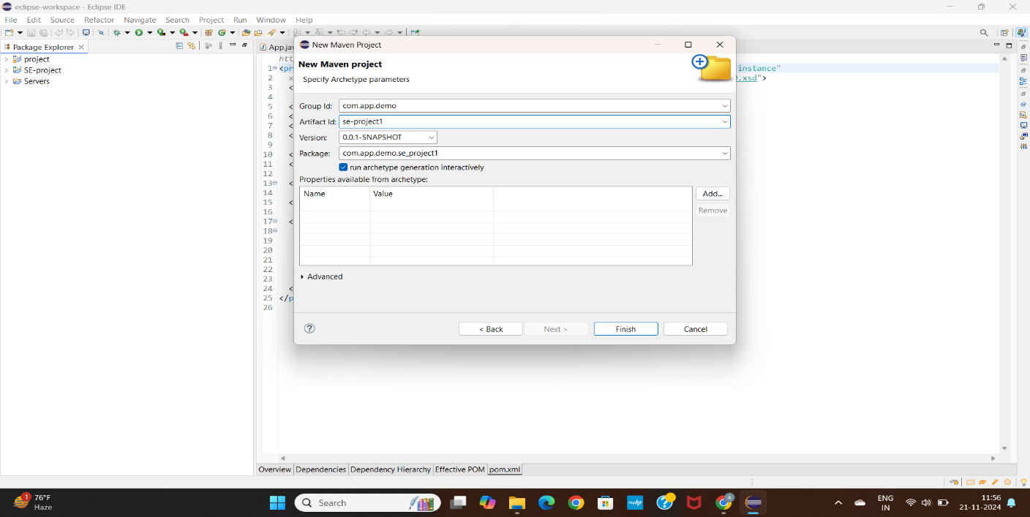

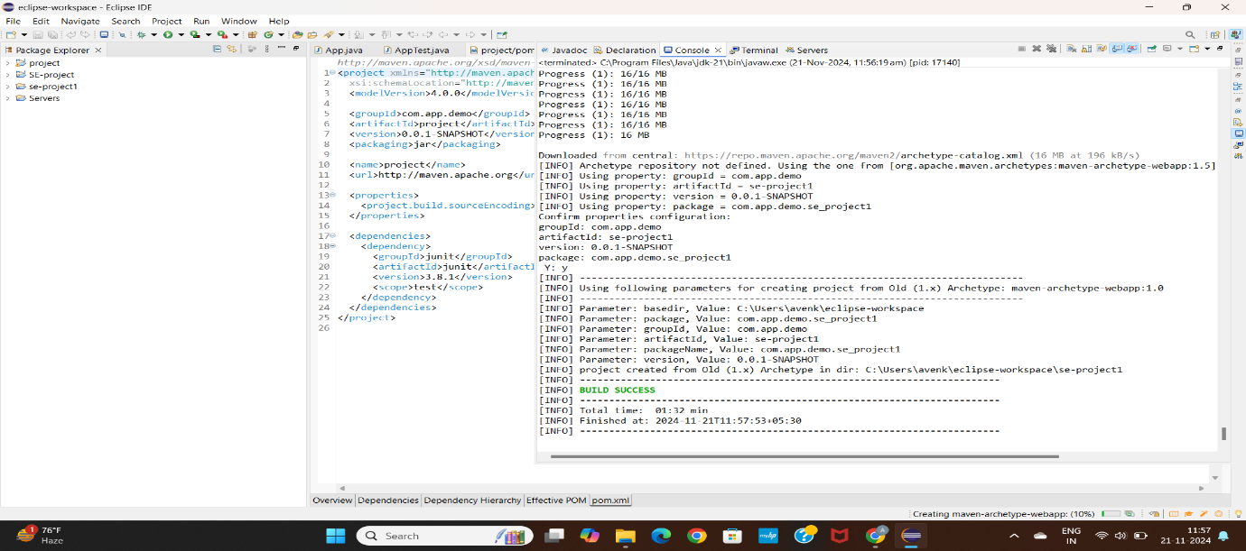

1. **Build the Maven Project**

* Right-click the project → Run As → Maven clean...
* In the Goals field, type clean install and click Run.

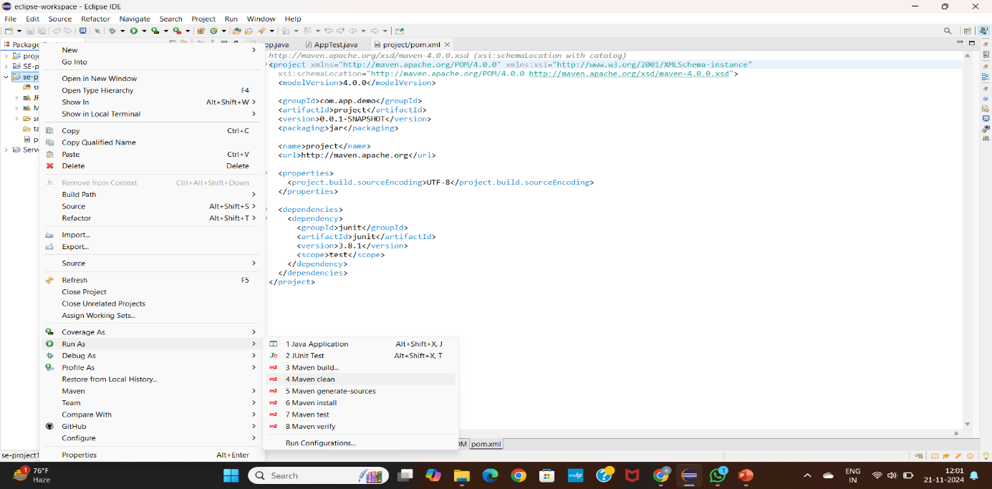

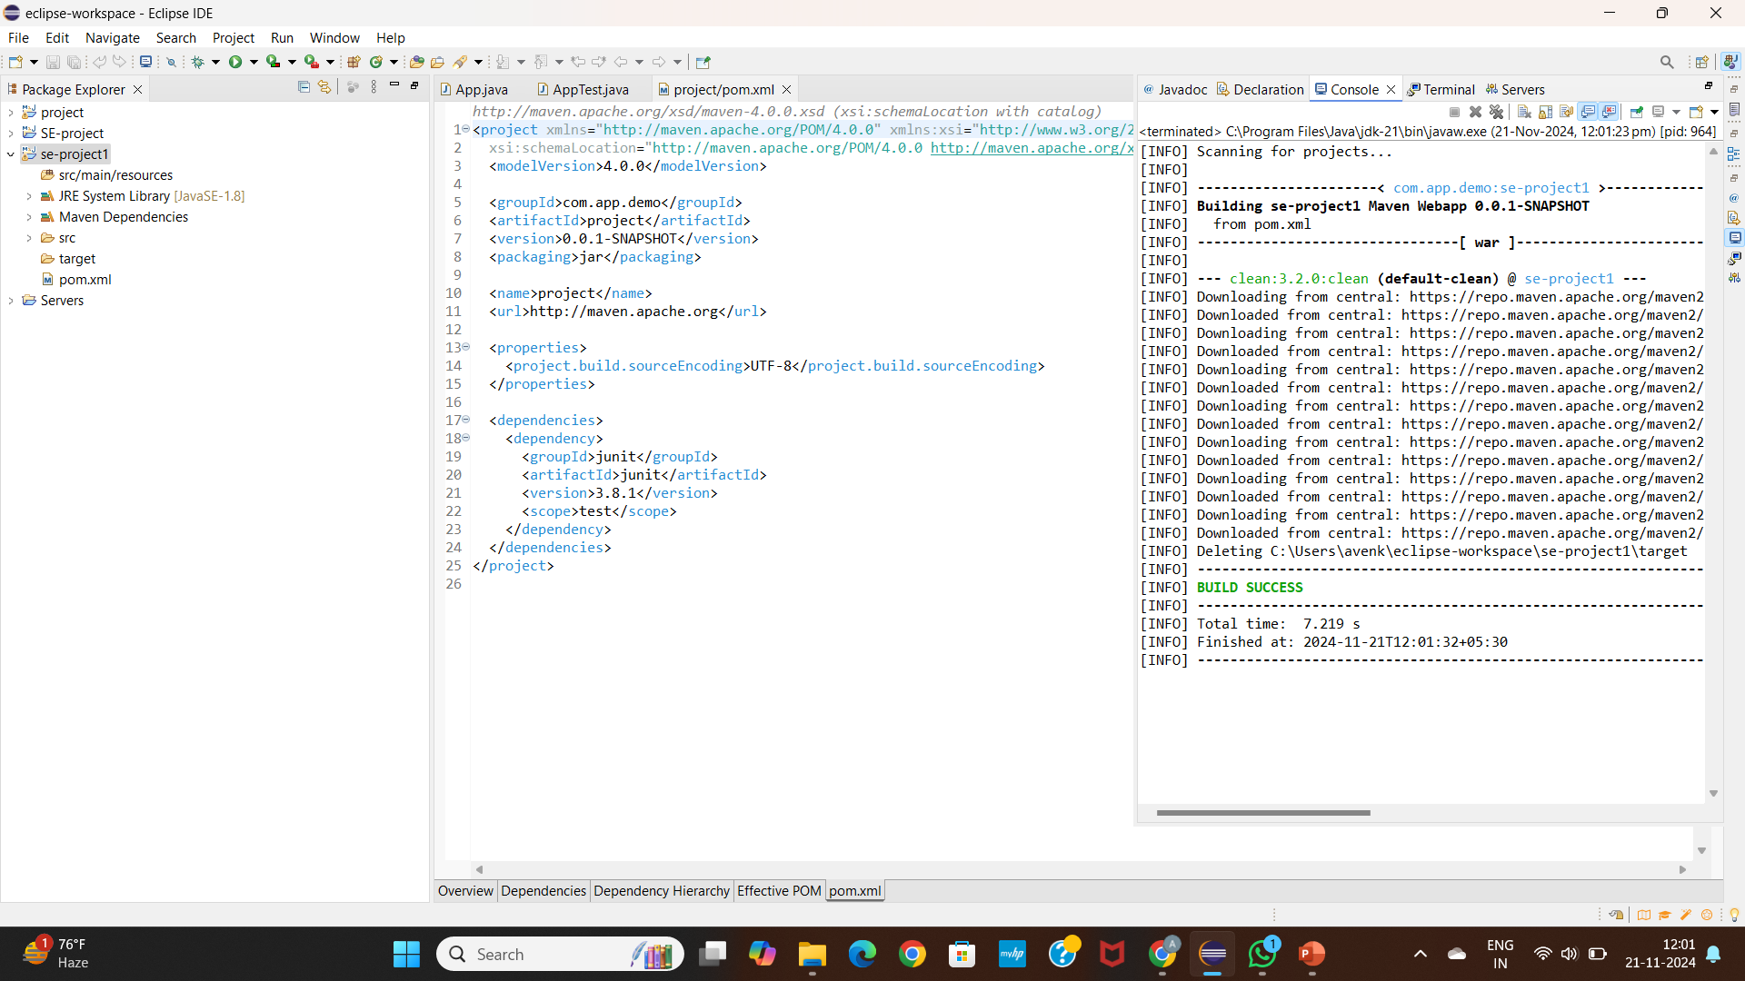

* Right-click the project → Run As → Maven install...

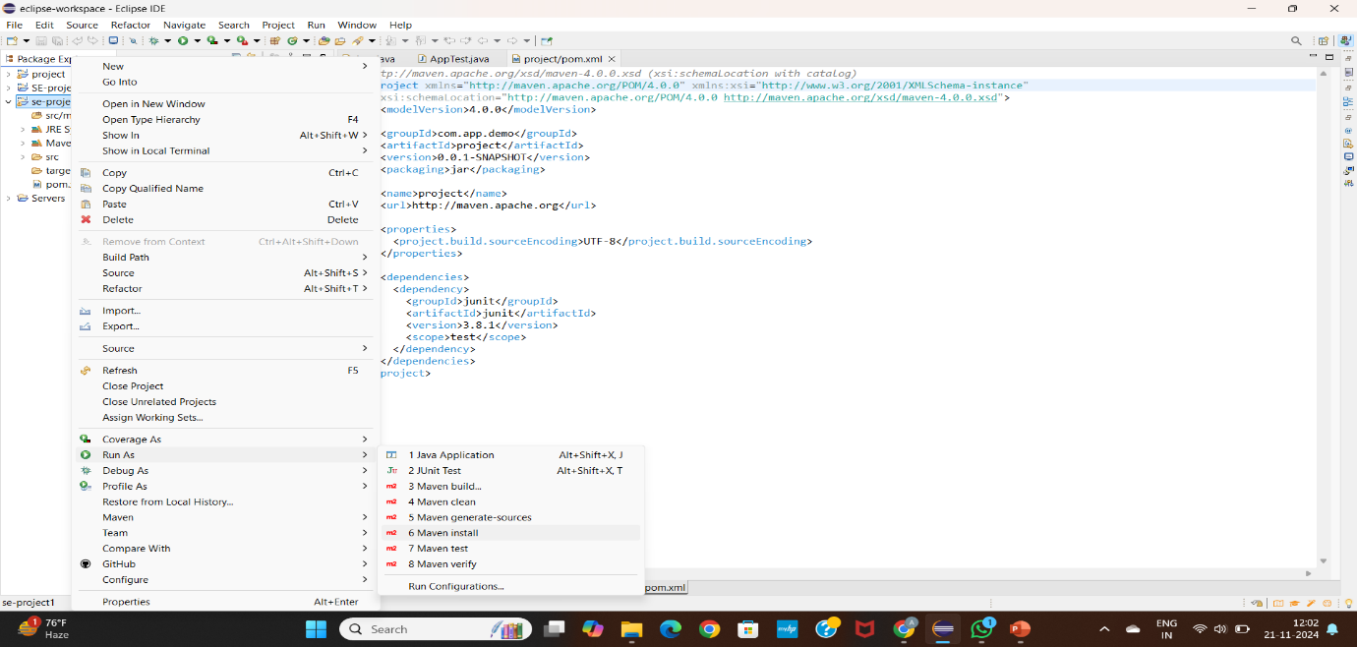

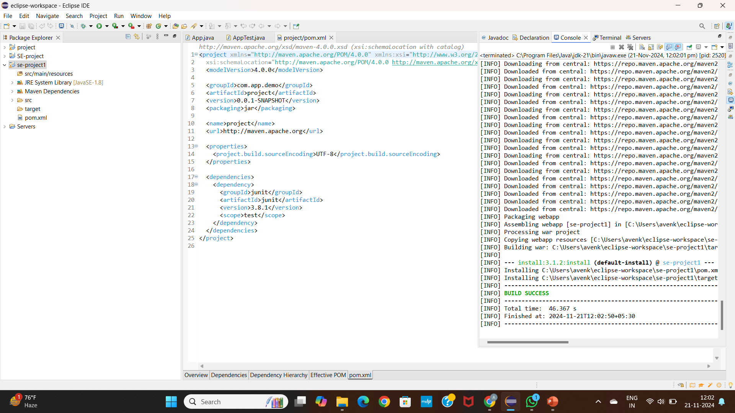

* Right-click the project → Run As → Maven test and build...

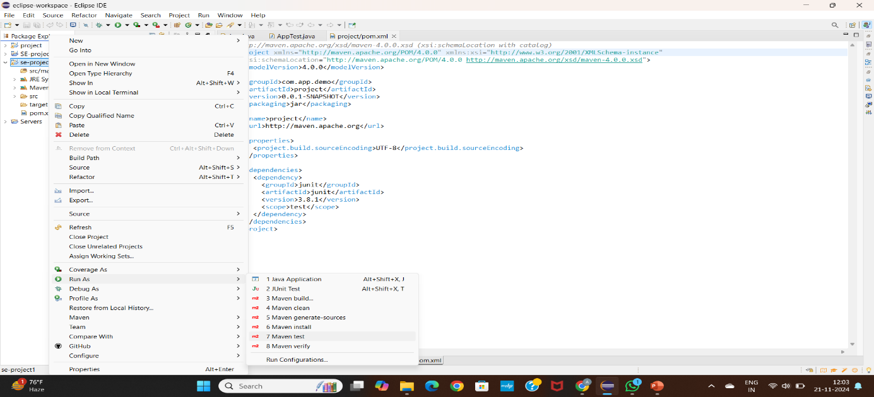

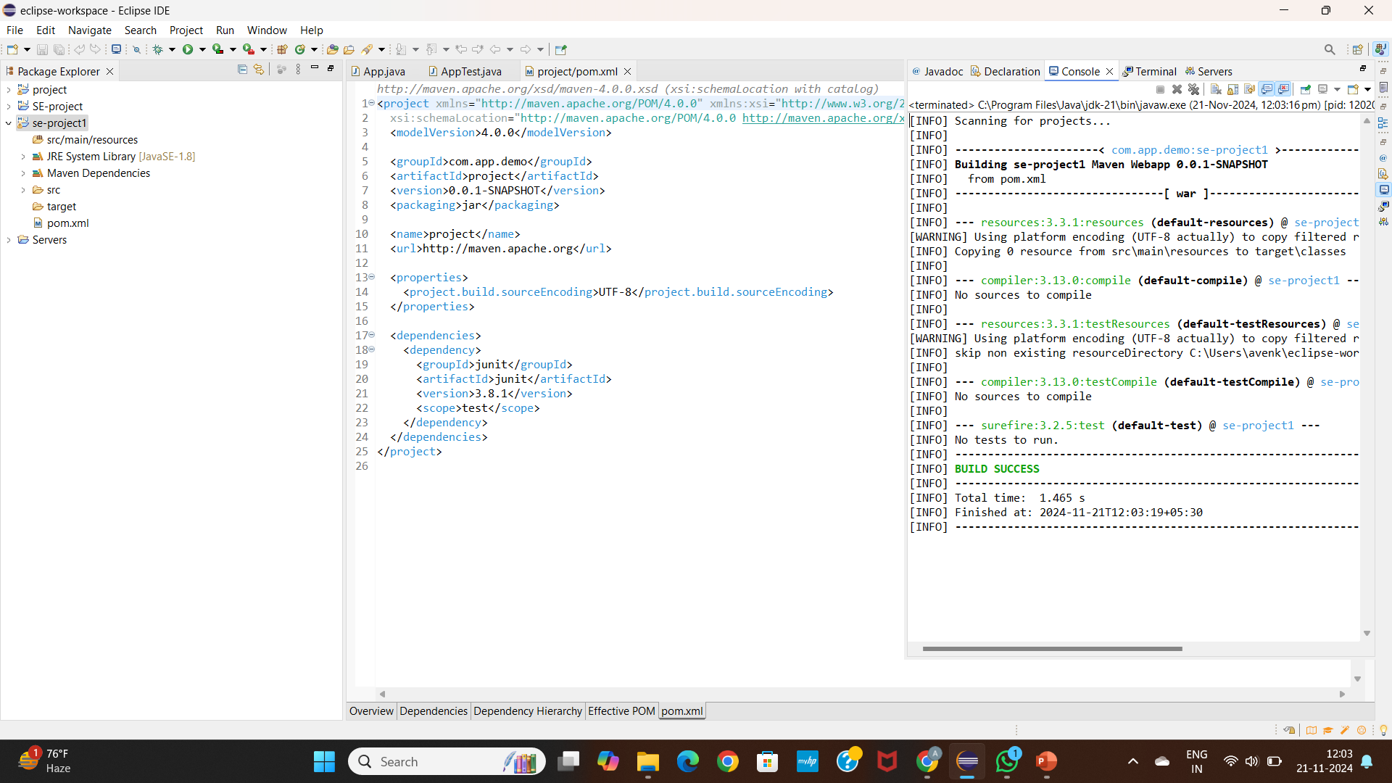

* In the Goals field, type clean install and click Run.

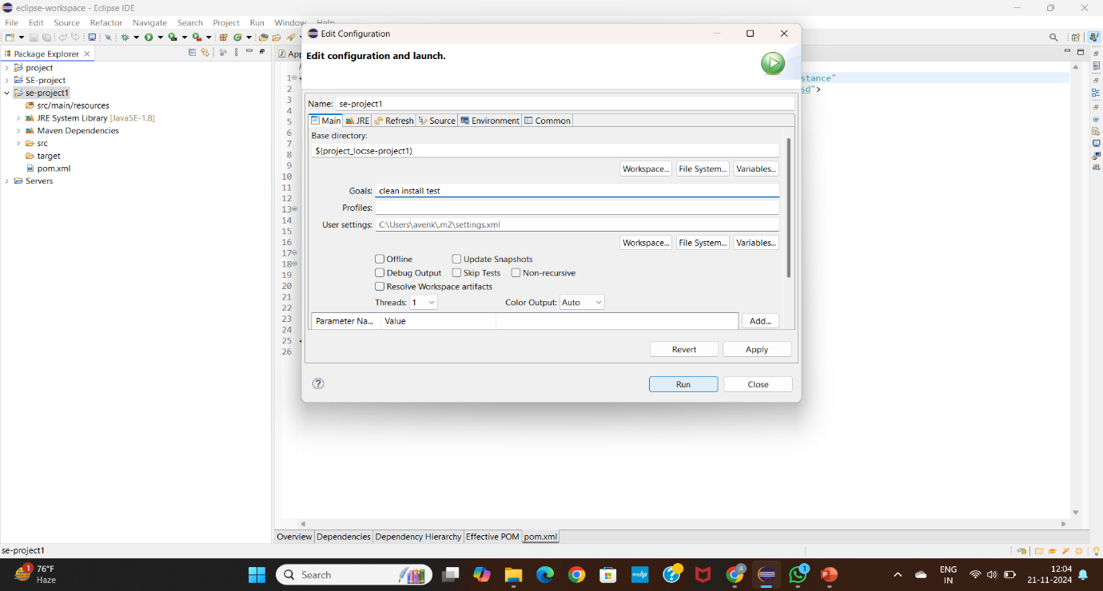

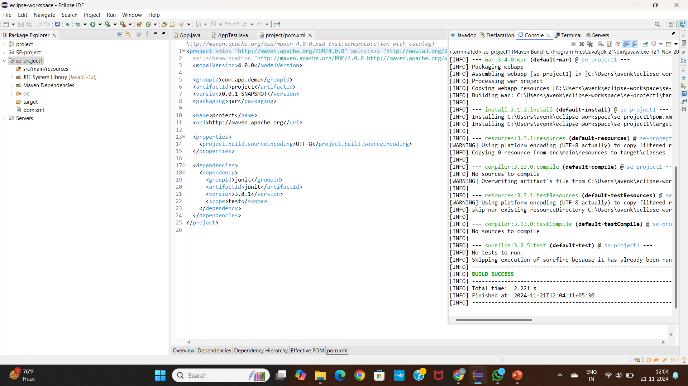

In pom.xml add dependencies as shown below

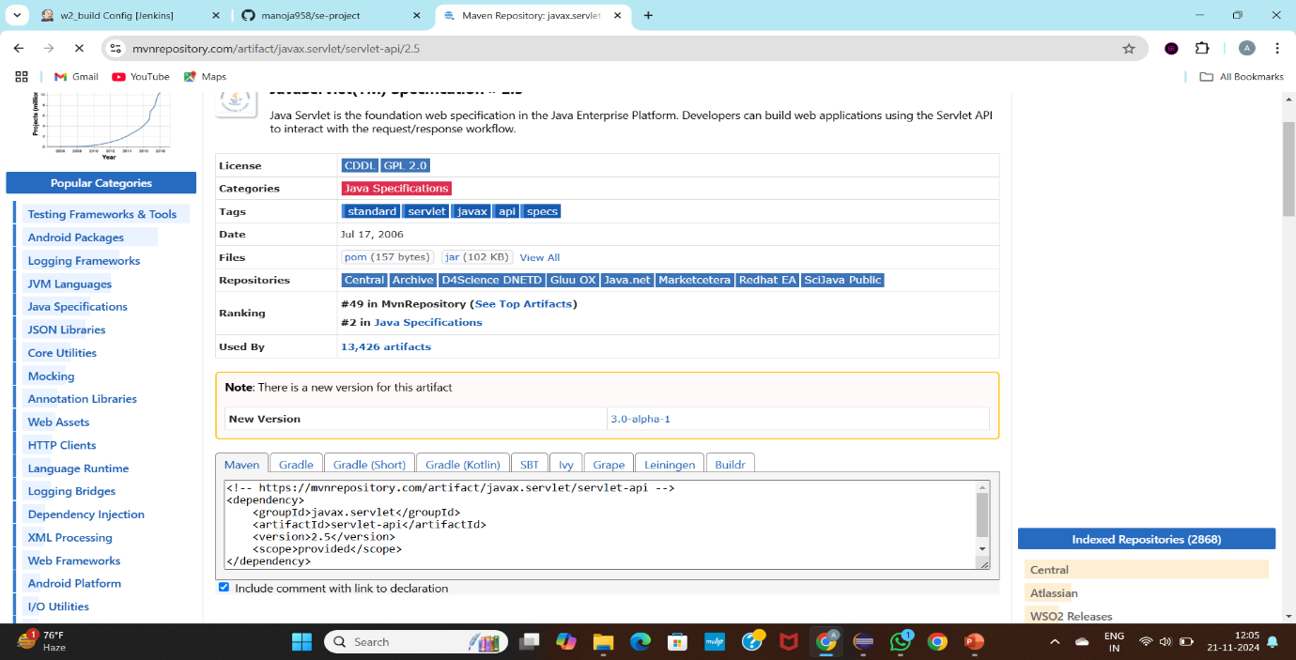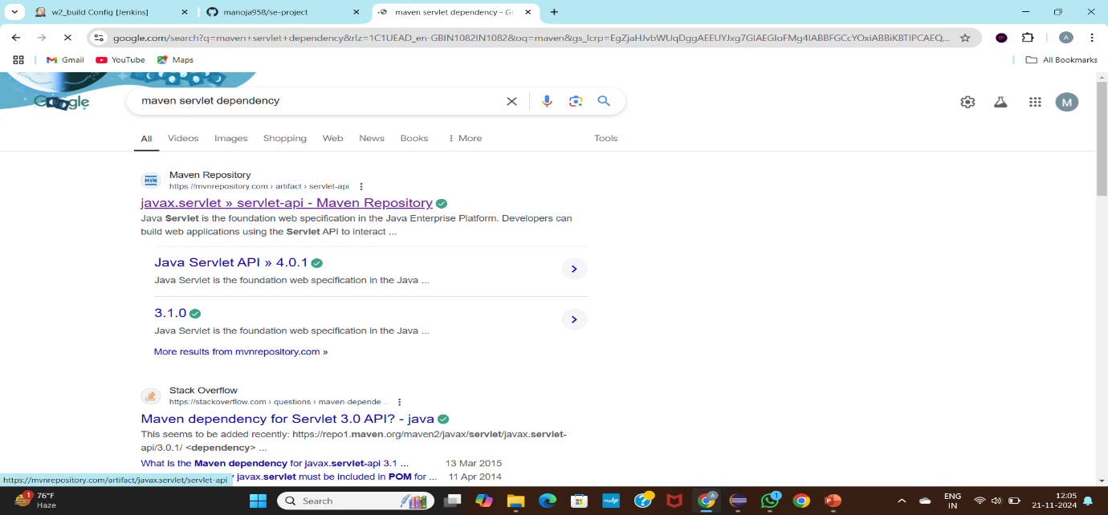

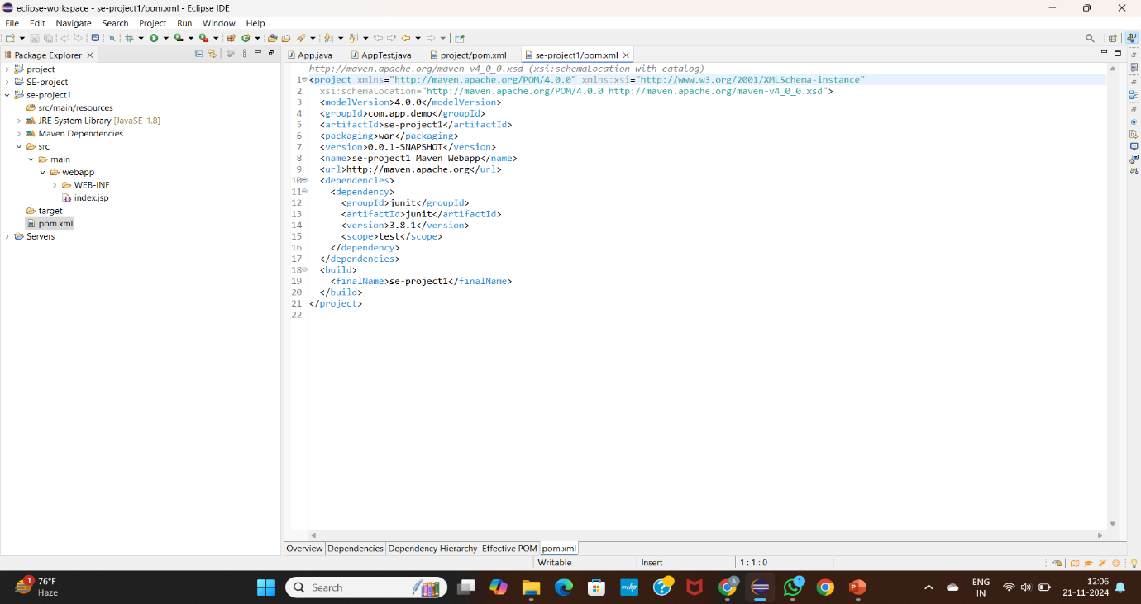

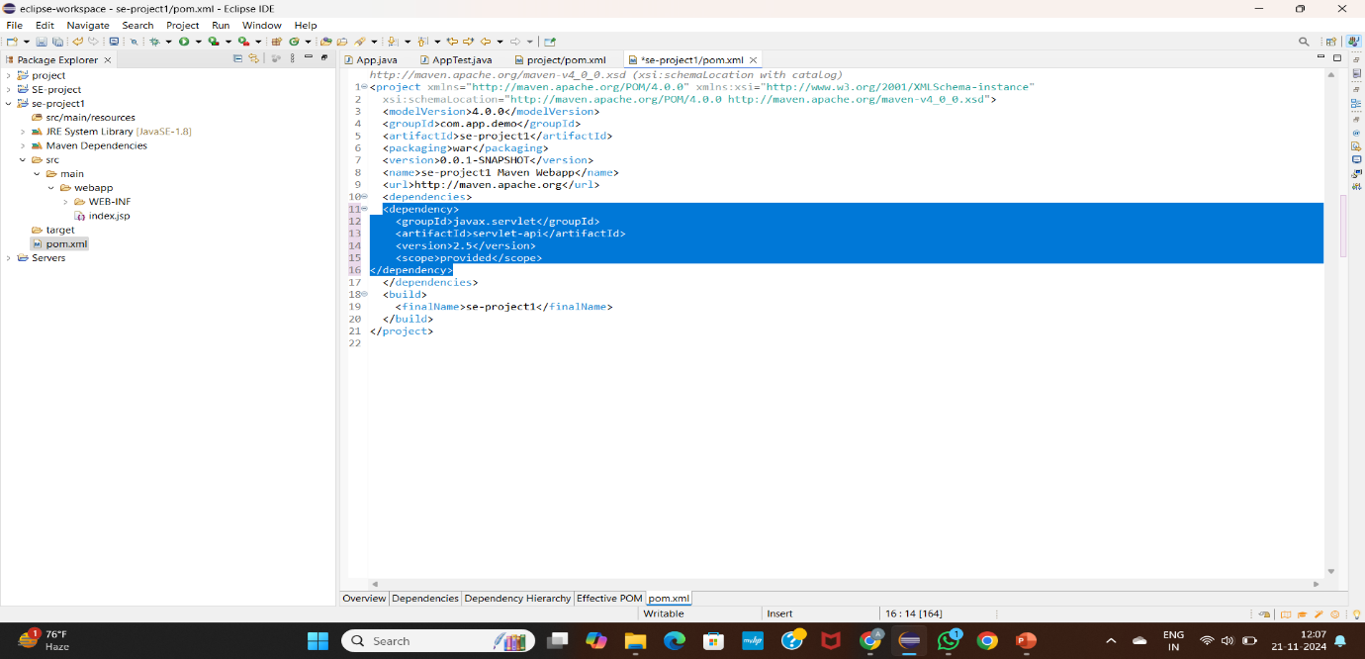

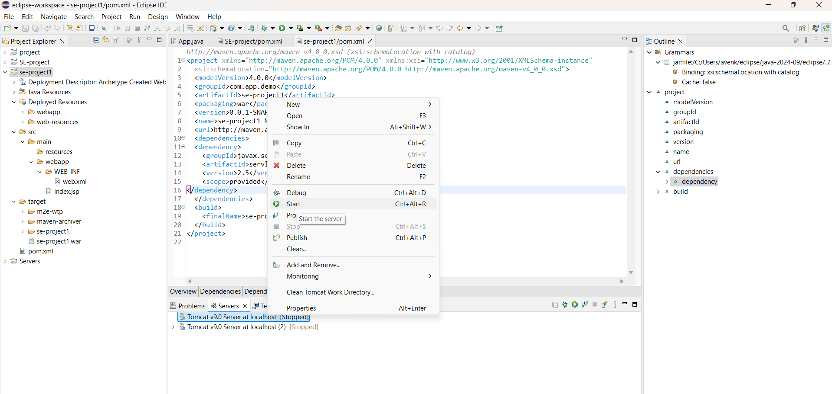

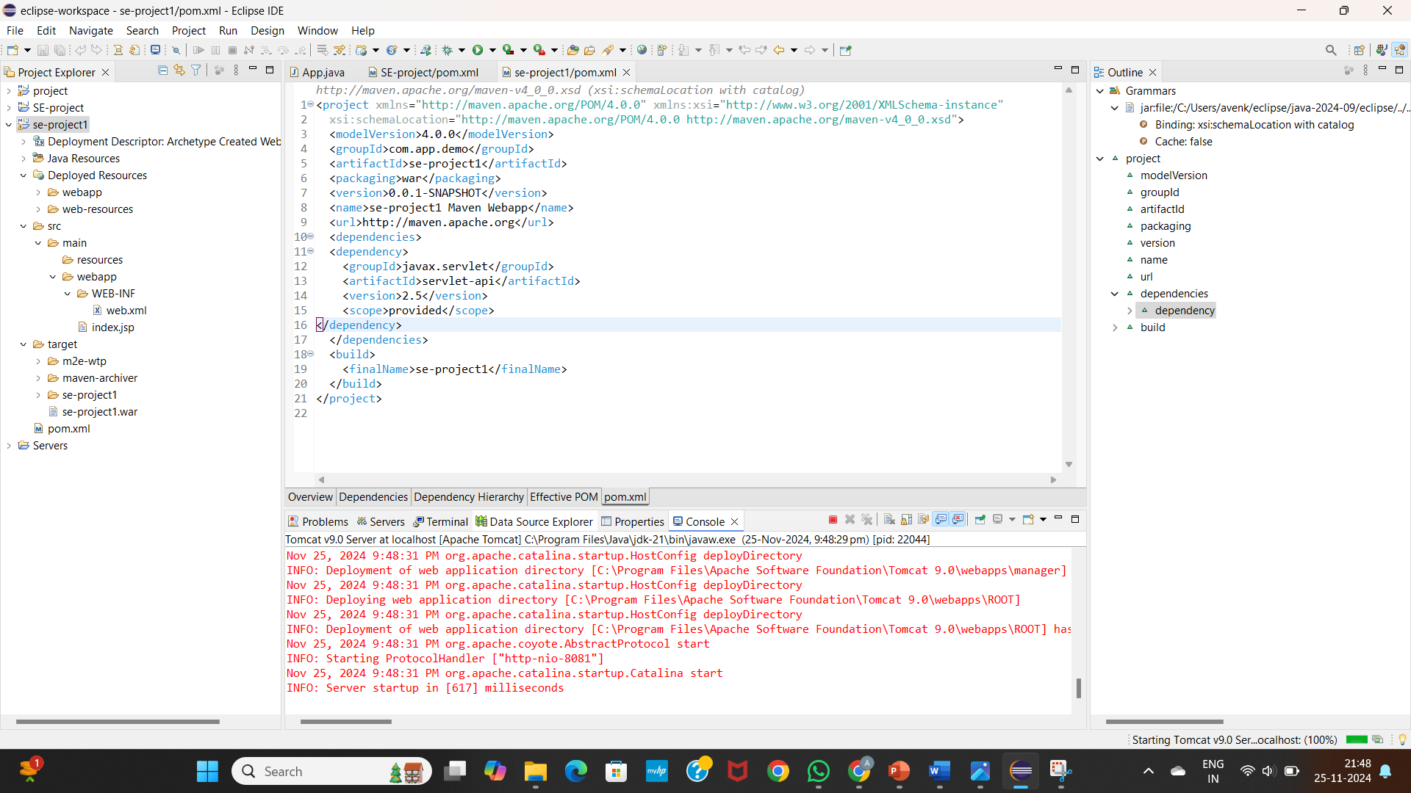

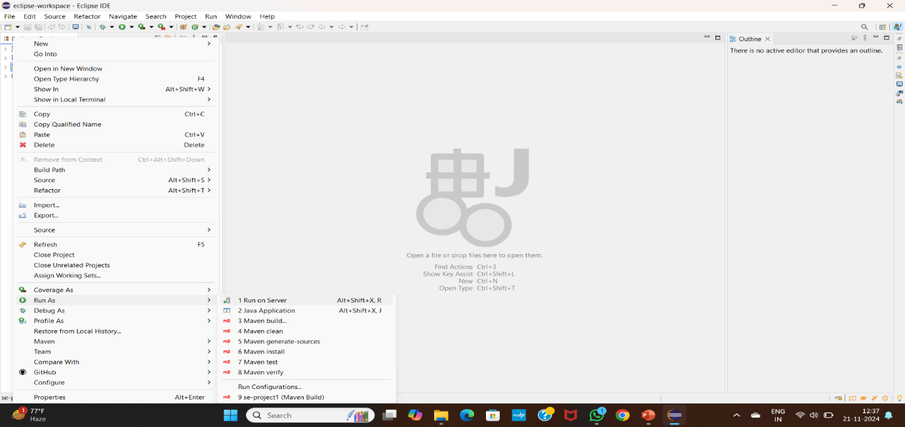

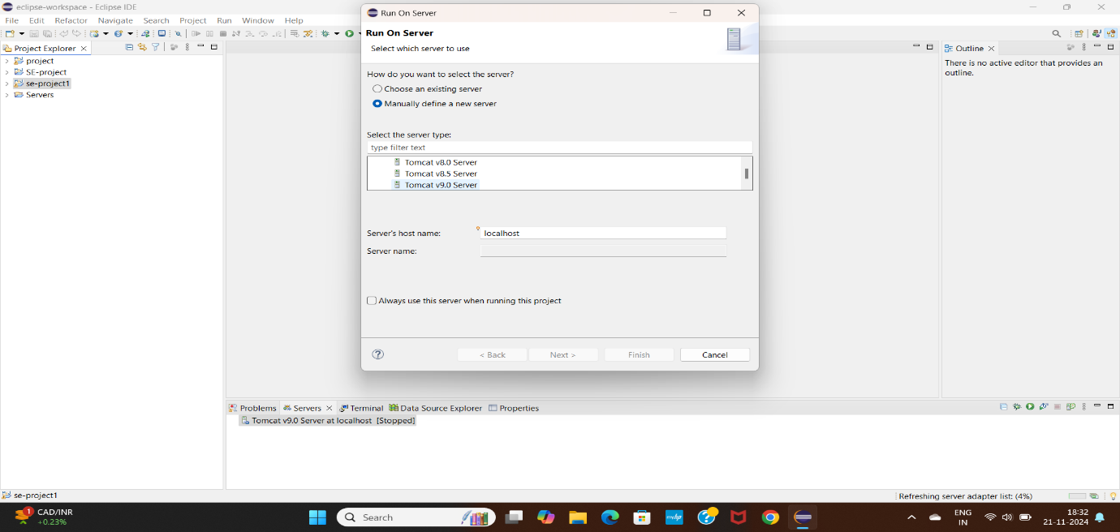

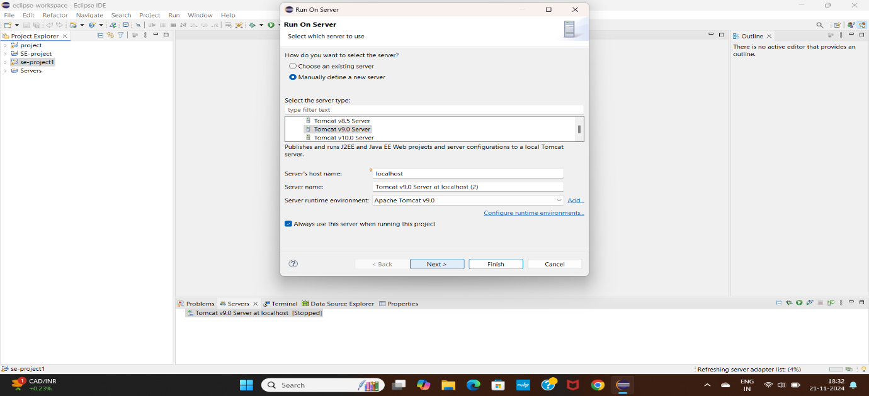

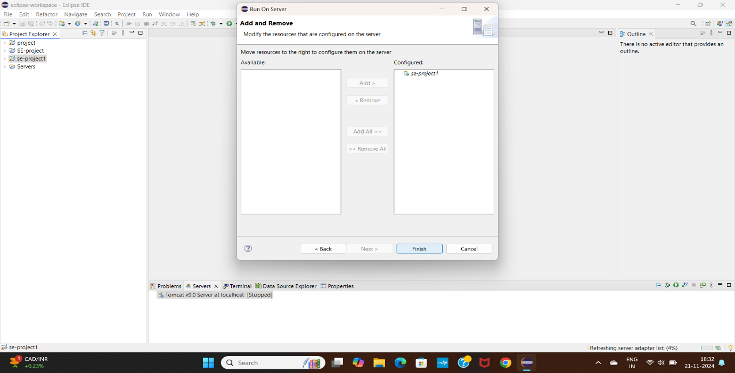

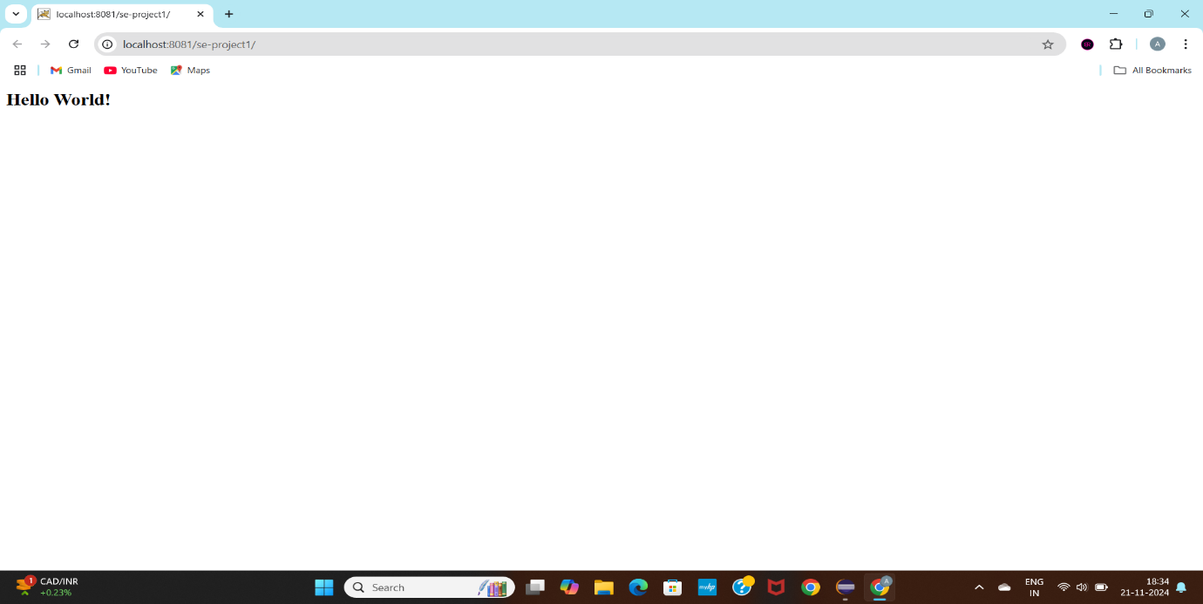

**1. Create a Remote Repository**

1. Go to [GitHub](https://github.com).
2. Create a new repository

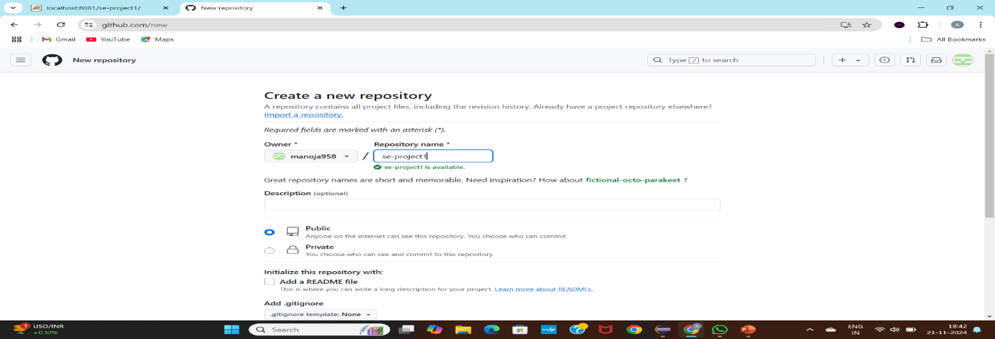

3.Link Local Repo to Remote.

4. Push Your Code.

5. Verify on GitHub.

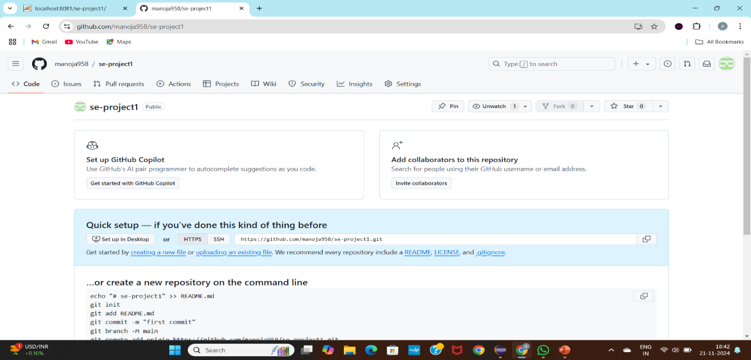

**Push the project into git:**

**1. Initialize a Git Repository**

Open a terminal or command prompt in the root directory of your Maven project.

Initialize the Git repository.

**2. Stage and Commit Files**

Stage all files and commit: 